**Idioms Against Humanity**

**Class time needed for lesson:** 10-15 minutes

**Class size taught:** 30-40 students

**Target audience:** SHS

**Objective:** To teach students fun and practical uses of common idioms.

目的：慣用語を楽しく実用的に学ぶ

**Materials:**

* Idioms Cards: A set of printed cards with common idioms written on them. (See Figure A)
* Tokens (coins, erasers, poker chips, etc.)
* Game Board (See Figure B)
* Dice

**Procedure:**

1. Play this game in pairs or groups of three. Each player should put a different token on START. Players will take turns, beginning with the person whose birthday comes first in the year.
2. When it is your turn, draw a card and read the idiom aloud. The other players complete the idiom, turning it into an idiom about YOU.
3. The one that is closest to something you would say (or something you find the funniest) would roll the dice and move ahead on the game board. Follow any rules written on the spaces.
4. The first person to reach FINISH is the winner.

**Additional information:**

This is a very quick, easy game that is simple to explain and doesn't require a lot of time. Because idioms often have a bit of humor in them, students enjoy making funny statements about themselves to their friends. This game is a good way to get classes who are reluctant to talk to start speaking with each other.

**Figure A**

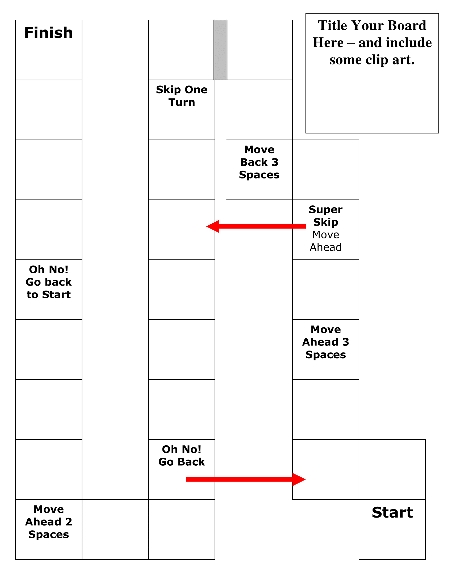

**Figure B**