Alien Spelling Game
Class time needed for lesson: 10+ minutes
Class size taught: Any size
Target audience: 4th year ES students and above
Objective: Practice identifying letters, spelling learned words, and getting used to using the dictionary.
目的：アルファベットと習った単語のスペリングを練習する。辞書を使うことに慣れる
Materials: Chalk, blackboard, and students’ textbooks
Procedure:
This is an alternative version of hangman.
- Have students flip to the glossary/word list section of their textbooks.
  - “Open your textbooks to page 115.” “I will choose ONE word.”
- Draw an alien, a house with a stick figure inside.
- Write the amount of lines needed for a word. Start with a short word such as “dog” or “cat”.
- Explain that you will choose a word from the glossary/ word list and they have to guess the letters and words. (I usually explain in English while using exaggerated movements. Students will pick up on the rules as they watch you and the HRT.)
  - “I will choose ONE word. Please guess the letters. What alphabet? Hmmmm.”
- Start the activity by asking the HRT to give you a few letters.
  - “Mr./Mrs.__, please give me an alphabet.”
- Similar to hangman, if the HRT gives the wrong letters, write it down and erase a portion of the house. (I usually erase 2 lines of the house per wrong letter.)
Example dialogue:
HRT: “S!”
ALT: “Aw, no!” *Erase 2 lines of the house.*
HRT: “K!”
ALT: “Oh, no!” *Erase 2 lines of the house.*
HRT: “O!”
ALT: “Yes!” *Write “o” on the line*

- After 3-4 letters, the students should have picked up the rules. Have students give you letters. If needed, have the HRT check the rules with them.
- Depending on the class:
  - Students can guess the answer as soon as they know it.
  - If enough students seem to know the answer, have them spell the whole word before giving you the answer. This helps students who aren’t comfortable with the alphabet.
- To make it more fun, have whatever remains of the stick figure fight off the alien (“alien beam”, “English beam”, “one punch!”, etc).

Additional information:
Don’t worry if you can’t draw! Have fun with it. Students will have a hoot seeing something ridiculous. (Ex: the alien can be a UFO, E.T., an octopus, Pikachu, etc.) Ask the homeroom teacher to draw the alien and erase parts of the house so you’re not all over the chalkboard writing, erasing, and drawing while calling on students.
Before:
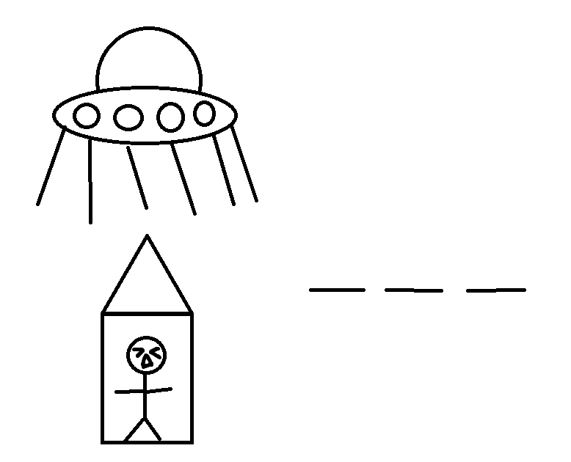
After:
