Small Talk Bingo + Variations
Class time needed for lesson: 5-15 min
Class size taught: Any class size
Target audience: ES 3rd-6th
Objective: In preparation for a lesson, teachers will learn how to make the small talk warmup more engaging by creating variations to the well known game of “Bingo,” while also rehearsing the target vocabulary and grammar.
目的：ビンゴゲームを通して、スモールトークのウォームアップをより魅力的にし、さらに語彙や文法の復習をする。
Materials: Blank bingo sheets (3x3 for warm up, 4x4 for longer activities, instructions are optional), Students: pencil or black pen, red and/or blue pencil or pen

Procedure:
- Review Target: 1-2 min
  - The teacher will begin the class by reviewing the material that the class has learned.
- Depending on the level of the class, this can be only vocabulary or only grammar. In any case, it should be materials that were previously introduced in another class.
- If the teacher has flashcards, put them on the board so the students can see them clearly.
- Preparation: ~2 min
  - The teacher will pass out the bingo sheets and have the students write their names.
  - Next, the teacher sets a timer for 1-2 minutes while students fill in the boxes with the vocabulary previously reviewed. The teacher uses this time to write the target script on the board.
- Younger or lower level students may use Japanese or katakana, but higher level students should be encouraged to write in English if there is time.
  - The teacher reviews the target script one last time before the activity starts to affirm students know their roles.
- Ex.: (Students write months) A: When is your birthday? B: My birthday is November 9th. How about you? A: My birthday is May 13th. See you. (Students A and B mark their Bingo sheets accordingly.)

- The prep time will decrease the more often you play this game and as the students become more familiar with the procedure.
- Bingo Game:~3-5 min
  - The teacher has students stand up before starting the timer for a designated amount of time.
    - The teacher should walk around to assist and make sure students are using proper English.
  - When the timer has finished, the teacher has students return to their seats and checks how many bingos the class got.
    - The teacher can also award stickers to the students with the highest (or lowest) number of bingos.
  - For additional review, the teacher asks follow-up questions to see what the students remember about their conversations.
    - Ex.: ALT: Who can swim? Student: Takeru can swim.
- Variations
  - Basic Bingo: Students ask questions with one answer (birthday, favorite color, etc.), and only mark their bingo sheets when they find a match.
- This can be a single topic for younger grades, or a mix of topics for older students. Ideally, there will only be one grammar structure to not confuse students.
  - Yes/No , Maru/Batsu Bingo: Students ask “Yes/No” questions from their sheet
    - Ex. After the question, (“Do you like ~”, “Can you ~” , etc.), students mark a blue circle (maru) for “Yes” answers and a red X (batsu) for “No”.
    - 3 circles OR 3 X’s can be bingos.
  - Line Bingo: Students are given a sheet with 7 boxes in a row rather than a grid. A bingo is still 3 sequential circles or crosses.
  - Interview Bingo: Instead of walking around, students work only in pairs or groups to finish their bingo sheets.
    - This is more ideal for high energy classes.
  - Bongo: Students are given a prefilled sheet and they choose a given number of squares.
    - If a student crosses out their selected squares, they have a “Bongo.”
Additional Information:
- Bingo as small talk is intended to break up the typical monotony of class time and get the students in a positive mood. As such, this should only be used once or twice in a lesson, rather than the new normal.
- All bingo sheets included were created by the author.
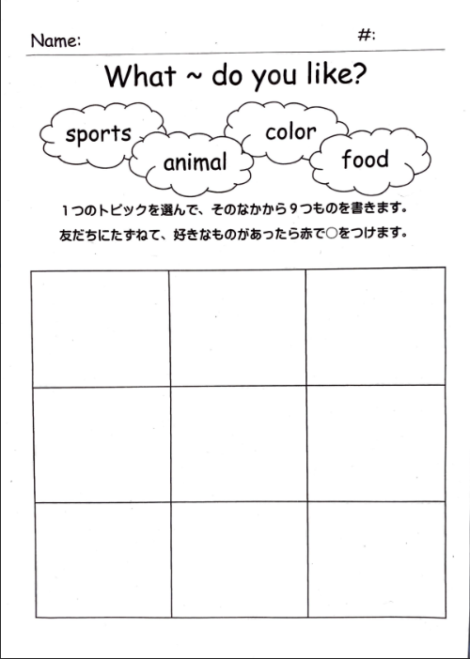
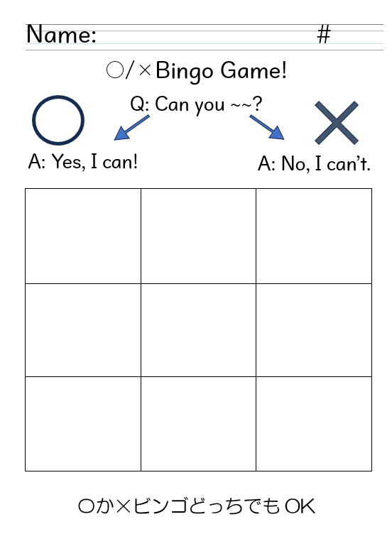
Examples:

