Finger Twister: Vocabulary Game
Class time needed for lesson: 10-15 minutes
Class size taught: 25
Target audience: ES - 4th grade
Objective: In a 10-minute game, students will use physical movement and repetition to practice target vocabulary and sight reading by placing their fingers on the game boards.
目的：10分間のゲームで、指をゲーム盤の上に置く身体的な動きと語彙を読み上げる反復練習を行い、ターゲットとなる語彙の定着を図る。
Materials: Printed game board with target vocab in circles (for example, days of the week), Optional: A spinner or some other method of randomly choosing numbers and vocabulary

Procedure:
- Introduction - 5 minutes
  - The teachers should review target vocabulary with students before the game begins.
  - The teachers will explain to the students that each finger will be assigned a number 1-5 (eg. 1 corresponds to the thumb, 2 corresponds to the pointer finger, 3 corresponds to middle finger, etc.).
    - It helps to trace a hand on the blackboard and write the number over each finger.
  - The teachers will explain and demonstrate the game to the students.
- Main Activity - 10 minutes
  - The students will receive individual game boards.
  - The teacher will call out a combination of numbers and target vocabulary (e.g. “1 - Tuesday”) .
  - Students will repeat the target vocabulary and place their thumbs on the circle with Tuesday.
  - The teacher will call out a new combination of numbers and target vocabulary (eg: “4 - Wednesday”).
  - The students will again repeat the target vocabulary and, while keeping their thumb on a Tuesday circle, they will place their ring finger on Wednesday.
  - These steps will repeat until the time for the activity is over.

Additional information:
Optional: It helps to reset the game after every couple of rounds, just so their fingers aren’t getting too twisted for too long. Also, allowing students to stretch their fingers between each round helps.
This is an activity I put together after having to play the “pointing game” or the “keyword game” too many times and becoming quite bored with this method.
I used this game with ES 4th year students when I noticed students having an issue remembering which English day of the week corresponds to which Japanese day of the week. This game was meant to have students hear the English name, say the English name, and point to the Japanese name, therefore making the connection mentally and physically. But this game can be a good way to practice sight reading or other language skills.

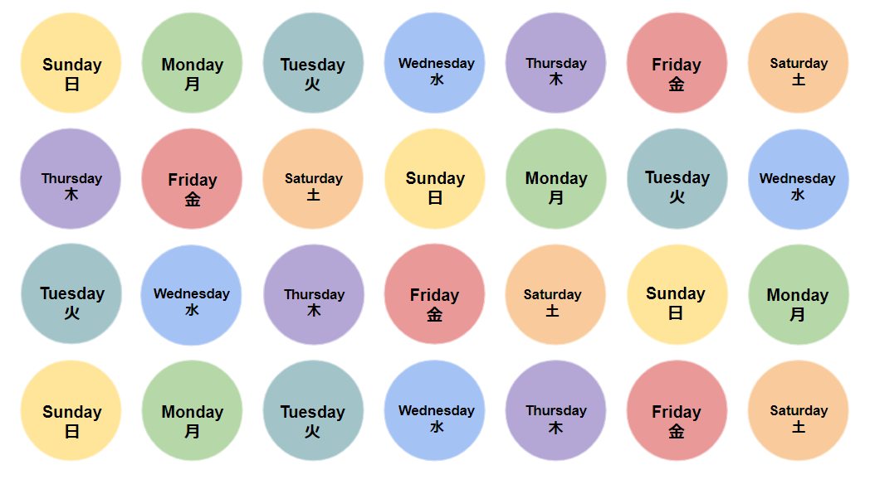
Example Finger Twister Game Board

