Let’s Introduce Ourselves!
Class time needed for lesson: 25-35 minutes
Class size taught: Any Size
Target audience: ES 6th Grade
Objective: Students will be able to give a simple introduction about themselves to their classmates.
目的：クラスメートに自分自身について簡単に紹介できるようになる。
Materials: Worksheets, Stamps (optional), Powerpoint Presentation

Procedure:
- Introduction - 2 minutes
- Teachers begin class with greetings and check the day’s goal.
- Main Activity - 20-30 minutes
- Self-Introduction (10-15 minutes)
  - First, the teachers show a short introductory powerpoint presentation of themselves or a character as an example. The presentation should address the simple questions on the worksheet.
  - Next, the students will write their answers on the front side of the worksheet (name, favorite food, animal, and sport). Students are encouraged to use their picture dictionary and/or ask the teachers for spelling help.
- Conversation Practice (10-15 minutes)
  - First, the teachers show and review the questions using repetition practice(1x).
  - Next, the teachers will demonstrate the conversation.
  - Lastly, the students will be given conversation time. Each student should use the questions in order to both practice speaking and fill their chart. Since the chart has 4 questions and requires 3 responses, ideally (depending on the classroom size) students should introduce themselves at least 3x and gain 3 different responses.
- Conclusion - 3 minutes
In case of extra time volunteers can share and demonstrate the conversation with the ALT (and be given a stamp for participation).

Additional information:
This activity goes well with any type of new introduction or as a review of common English conversation for 6th grade. Also, if movement and exchange with students throughout the class is not encouraged, this activity can be done within groups/pairs.

Self-Introduction

英語で自己紹介

Hello!

What’s your name? おなまえは？
My name is
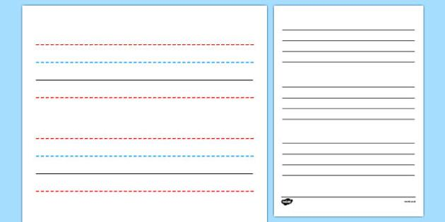

What food do you like? すきなたべものはなんですか？
I like

What animal do you like? すきなどうぶつはなんですか？
I like

What sport do you like? すきなスポーツはなんですか？
I like

Nice to meet you!

Please talk to 3 friends. ともだち3人とはなしてください。

 | 1 | 2 | 3
What’s your name?

おなまえは？
What food do you like?

すきなたべものはなんですか？
What animal do you like?

すきなどうぶつはなんですか？
What sport do you like?

すきなスポーツはなんですか？

