Who Ate Kito-Kito-kun’s Fish?!? (Passive Voice Murder Mystery)
Class time needed for lesson: 50 minutes
Class size taught: 30-40 students
Target audience: JHS or SHS
Objective: To review passive sentences in a fun way
目的：受動態を楽しく復習する。
Materials: Worksheets, images of Kito-Kito-kun and Buri-chan (can be found online), list of answers and hiding places, props (explained below)

Procedure:
I. Introduction – 5 minutes
- The ALT will show a picture of Kito-Kito-kun (with crying eyes photoshopped on him if possible) and say the following:
  - “Kito-Kito-kun is sad. Repeat after me: Oh, no! [WAIT FOR RESPONSE] Why is Kito-Kito-kun sad?? [WAIT FOR RESPONSE] Kito-Kito-kun is sad because his fish, Buri-chan, was stolen yesterday! [SHOW PICTURE OF THE SHINKANSEN FISH KITO-KITO-KUN SOMETIMES HOLDS] Buri-chan was loved by many people. But, some teachers at [INSERT HIGH SCHOOL NAME] like to eat fish… Did someone eat Buri-chan?!?!?”
- The ALT will explain that this is not just any mystery game, it’s a MURDER MYSTERY!
II. Main Activity – 35 minutes
- The ALT will pass out the worksheets. The worksheets contain scrambled passive sentences and a list of teachers. The ALT will explain the instructions:
  - The unscrambled sentences will lead them to clues that are hidden around the room.
  - Students must use the clues to figure out which of the teachers on the worksheet ate Buri-chan.
  - After they think they know who ate Buri-chan, they must write down their reasoning and submit it to the ALT or JTL. Their answer will only be accepted if the passive sentences were all unscrambled correctly.
    - *Note that students may check their unscrambled sentences with the ALT or JTL anytime during the game.
- As students play the game, the ALT and JTL will provide support, checking the unscrambled sentences, helping decipher the clues, and pointing students in the right direction of clues as needed.

III. Conclusion – 10 minutes
- Once most groups think they have figured out who ate Buri-chan and have written down their reasons, direct students back to their seats.
- Go group by group, asking students to state who they suspect and why.
- Reveal the answer at the end (in the example game materials provided, the answer is Saitou-sensei).
  - *Note: It is advised to replace the names with names from the ALT’s own school.
- The winning group(s) may get a small candy, stickers, etc. as a prize.

Additional information:
This lesson has always had students form groups rather than working alone.

To avoid congestion around any of the hidden clues, it would be beneficial to create a few different versions of the worksheet in which the passive sentences are in different orders. Past experience shows that 4 versions of the worksheet is enough.
- *Note: Sentences 6 and 7 of the provided worksheet lead to very big hints, so it is advisable to keep these in their current positions.

Unscrambled passive sentences on the worksheet:
  - A paper is hidden in the teacher’s desk.
  - A note is hidden in a pen. The pen was placed on the floor.
  - Go talk to ALT. A hint will be written by them.
  - A note was taped on the door.
  - Kito-Kito-kun was spoken to by JTL. Find the pink heart paper.
  - JTL was sent a postcard by Buri-chan. Find the envelope labeled “Postcard.”
  - A note was put inside the bell.

Breakdown of the hidden clues:
- “Paper in the teacher’s desk”
  - A “page from Kito-Kito-kun’s diary” (see image A)
- “Note in pen on the floor”
  - An empty pen with a post-it note hidden inside, which reads: “Teachers with names that begin with K did not eat Buri-chan” (see image B)
- “Hint written by ALT”
  - “It wasn’t XXX-sensei”
- “Note taped on door”
  - A paper with a list of teacher’s fish preferences (see image C)
- “Pink heart paper”
  - A paper which reads” Buri-chan was eaten by a male teacher” (see image D)
- “Ikemen-sensei’s postcard”
  - An envelope with a postcard from Buri-chan to Ikemen-sensei (see image E)
- “Note inside a bell”
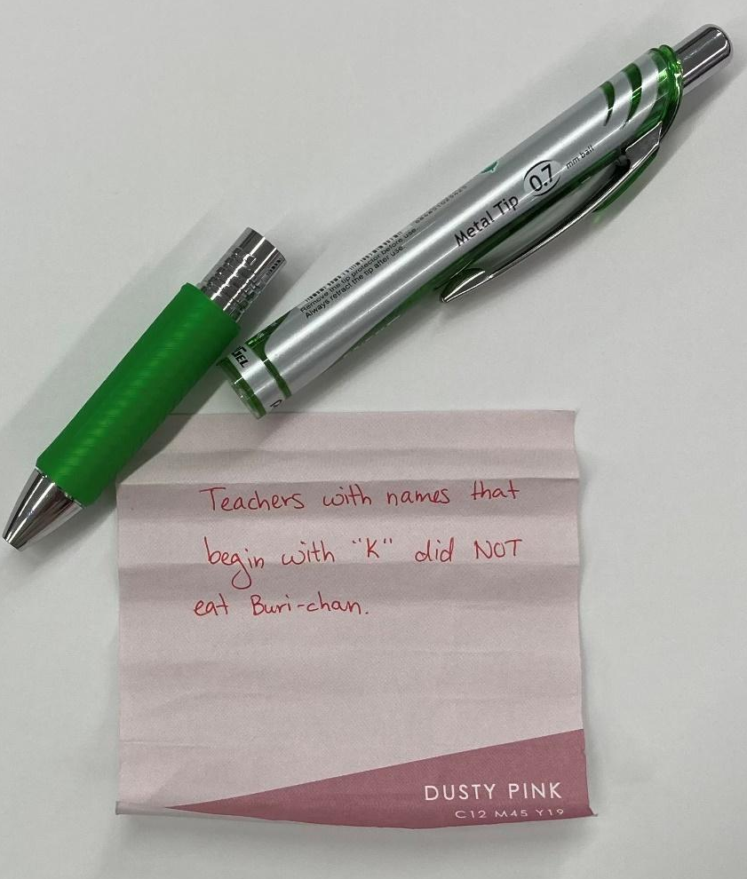
  - A bell with a personal note inside from one of the teachers which tells students Buri-chan was last seen with one teacher (see image F)
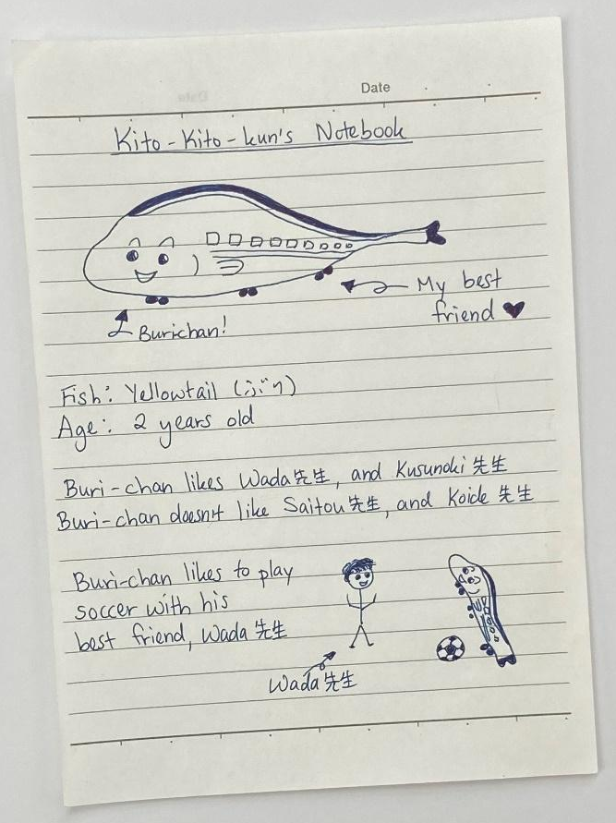
A
B

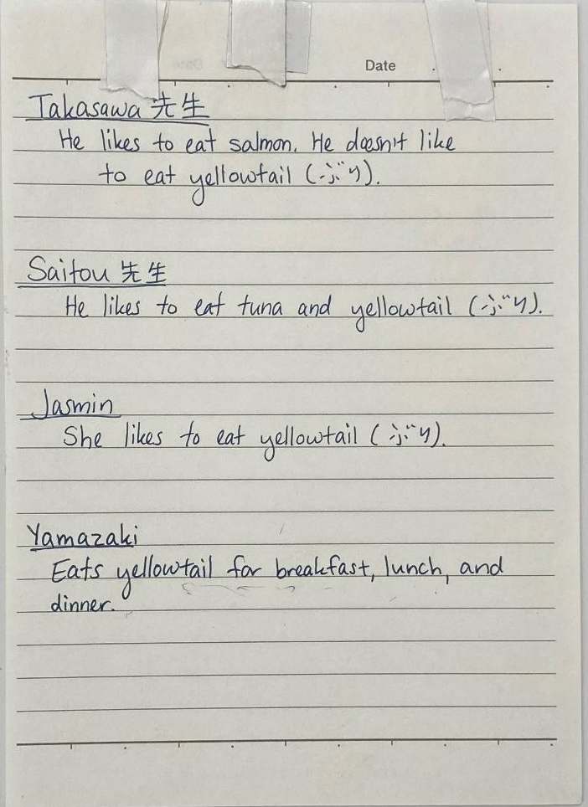
C

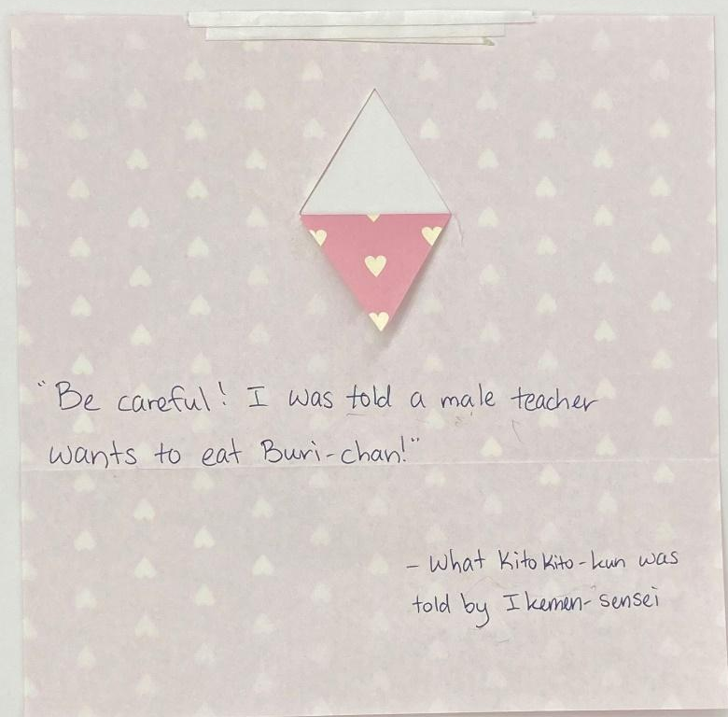
D

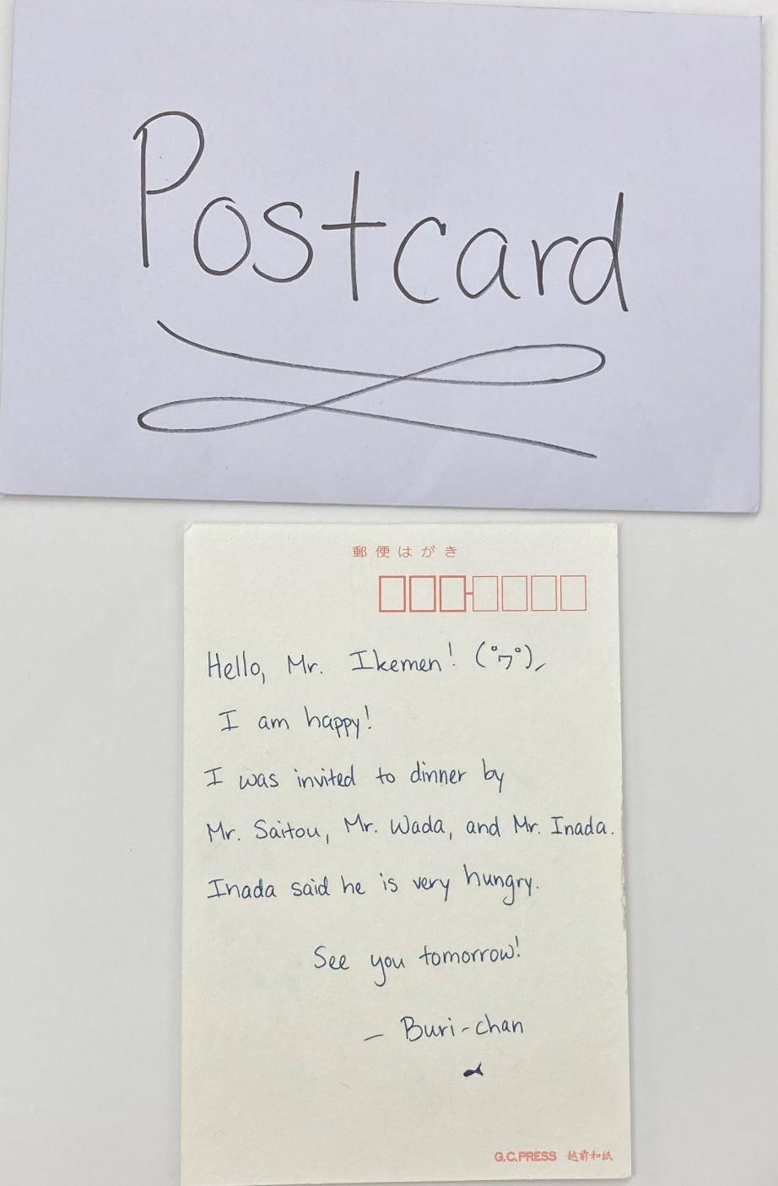
E

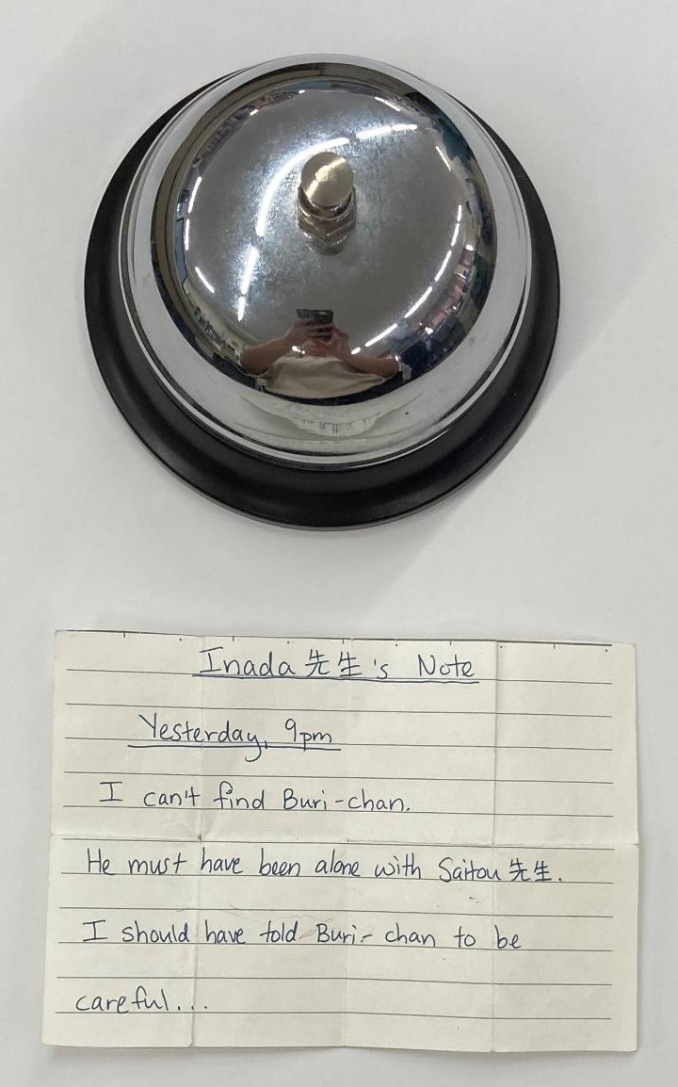
F

Who Ate Buri-Chan?!?

- teacher’s/a paper/in the/desk/hidden/is
____________________________________________________________________
- (is hidden/a note/pen/in a.) (on the/was placed/the pen/floor.)
____________________________________________________________________
- (Jasmin/to/go talk.) (a hint/by her/written/will be.)
____________________________________________________________________
- was taped/a note/ door/ on the
____________________________________________________________________
- by Ikemen-sensei/Kito-kito-kun/spoken to/was
____________________________________________________________________
- was sent/Ikemen-sensei/by Buri-chan/a postcard
____________________________________________________________________
- was put/the bell/a note/inside
____________________________________________________________________

Saitou先生 (M) | Yamazaki先生 (M) | Jasmin先生 (F)
Takasawa先生 (M) | Koide先生 (F) | Wada先生 (M)
Kusunoki先生 (M) | Inada先生 (M) | Ikemen先生 (M)

We think Buri-chan was eaten by ____________________先生, because ________________________________________________________________________________________________________________________________________________________________________________________________________________________________________________________________________________________________

