King’s Order
Class time needed for lesson: 50 minutes
Class size taught: 10+ students
Target audience: SHS
Objective: To review future tense and make use of vocabulary used for social problems.
目的：動詞の未来形を復習し、社会問題に関する単語を使う。
Materials: Game PowerPoint, scoresheet, “something for the students to write on” (for example: paper cards, reusable plastic cards, mini whiteboards), worksheets.

Procedure:
I. Introduction of game rules and forming teams – 10 minutes
- High-level classes can play this game individually, but it’s recommended to get people into pairs. The teacher splits the class into groups and asks them to move their tables together. Each group should have around 6 people or 6 pairs.
- The teacher passes out one score sheet per group. The teacher places one worksheet and one “something to write on” per person and or pair. The teacher explains the game rules:
  - The king has died, and the students are the new king. Ask them to write down their new country’s name on the score sheet.
  - There are 8 rounds, 8 categories (food, health, safety, money, education, environment, fun, relationships). For each round they have to write down 1 sentence from any category.
II. Writing sentences/preparation for the game– 10-15 minutes
- Following examples on the worksheet, each pair or person should try to write at least one sentence in each category using future tense. For example, “I will ban apples,” for food or “I will increase crime,” for safety. They don’t have to be a good person to win the game, as it is a semi-luck-based game.
Note: You can add more time for preparation, it is the most important part of the game.
II. Playing the game and scoring - 30 minutes or until the end of the lesson
- Before each round, the students pick one sentence from the ones they made and write them down on the “something to write on” thing.
- The teacher creates 8 scoring tables with colour-coordinated cells (Figure 1. and Figure 2.) on the Game PowerPoint. If the students’ chosen category is coloured in red - they lose 1 point. Yellow - 0 points. Green - gain 1 point.
- The king also receives a Letter From the People (also pre-written on the PowerPoint) with specific issues written down. For example “People are cold”. If the students wrote: food: I will sell more soup or environment: I will increase global

warming, they win an extra point, as it solves the issue of the people, regardless of the means. However, if they wrote: health: I will make people swim, or fun: I will make ice cream free in karaoke cafes, they will lose a point because they made people colder. I recommend writing 3 issues per letter, for example, “people are hungry”, “people have allergies”, and “people want crime”. It is possible to get no points here.
- The points come from the table shown below and the Letter From the People stack. So you can get +4 points in one round, or -4 if you were really unlucky and caused more issues for the people.
- Process: The students write an order from the king, then the ALT reveals the table, then the ALT reveals the Letter From the People, then the students write down the score on the score sheet.
- The winner of each group is the person or pair with the most points.

Figure 1. Figure 2.
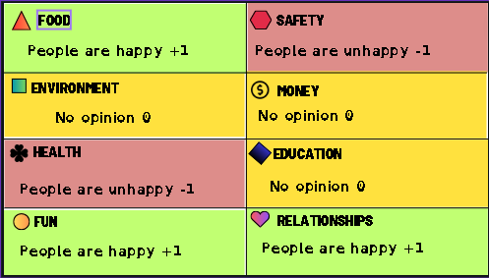
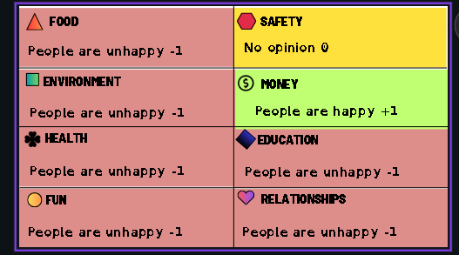



Score Sheet Example

