Passive Voice Mousetrap Machine
Class Time: 45 minutes (Can be extended to ~60 minutes across 2 class periods)
Class Size: 20-30 Students
Target Audience: 2nd -Year JHS
Objective: In one class, students will express at least 4 actions of their machine in passive voice.
目標: 受動態を使って機械の動作を表現することができるようになる。
Materials: Worksheets, Projector, Video, Japanese-English Dictionaries
Procedure:
- Introduction - 5 minutes
- Greet the students.
- Review the concept of “passive voice” (in Japanese,受け身 ukemi). An easy demonstration is to drop a ball:
“I drop the ball.” = 私がボールを落とす。Watashi ga bohru o otosu.
“The ball is dropped by me.” = ボールが私に落とされる。Bohru ga watashi ni otosareru.
- Ask students to come up with one simple sentence in English on their own. Give 3 minutes, and ask for volunteers. Take the volunteers’ sentences, and show how to turn them into passive voice. e.g. “I play baseball.” -> “Baseball is played by me.”
- Rube Goldberg Machine Video - 12 minutes
  - (2-5 min.) Before playing the video, ask the students to watch for things in the video they can express in passive voice in Japanese. Then, play the video once at normal speed. If time allows, you can play it twice.
  - (8 min.) Play the video at ½ to ¼ speed (YouTube has controls for this – I recommend muting the video, or using the pre-slowed video above). Pause after each action, and ask the students to describe what has happened in Japanese. Then, give the action in English. For example, using the links above:
    - “The string is pulled by the mouse.”
    - “The clock is [turned on/rung] by the string.”
    - “The string is pulled by the clock.”
    - “The saw is pulled by the string.”
    - “The wood is cut by the saw.” etc.
  - Write these verbs on the blackboard – they are probably new to most students, but they will be very useful for the next part of the class.
- Worksheet: Planning Phase - 10 minutes
  - Distribute the worksheet to all students.
  - Explain the instructions for the activity.
    - Students will work in groups of 3-4 to design their own machine.
    - In the box at the top, students write their machine’s purpose in an active voice. (eg. “It opens a door.”)
    - Students draw a picture of their machine in the space below.
    - Students write at least 4 actions done by their machine, but can write up to 7 in the space provided (example below). The machine shouldn’t be too complicated – it’s best to have them use English they already know.
  - Put the students in their groups. Give them time to speak and brainstorm their machine, but set a timer and keep them on track.
- Worksheet: Execution - 15 minutes
  - (3 min.) Once students have thought of their machine, they can start drawing their final version.
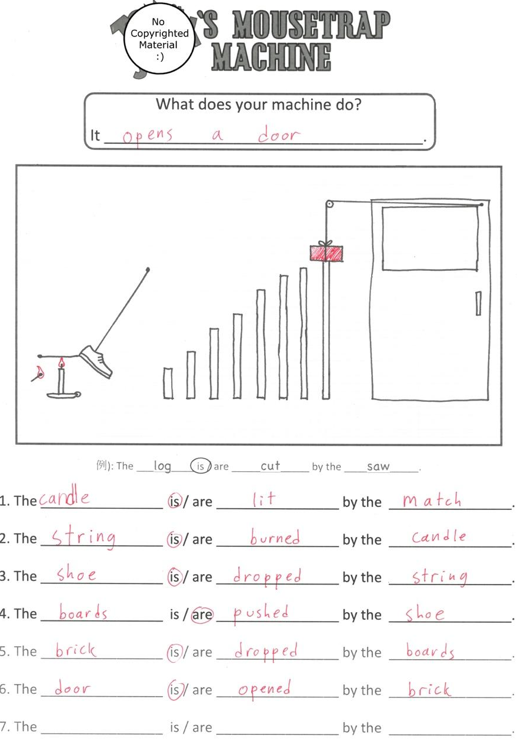
  - After drawing, students can start making sentences. They can use dictionaries or ask teachers for words they don’t know.
  - Collect and correct the worksheets at the end of class.

- Extension Possibilities - 15 minutes
  - This class can be extended into a second class period by incorporating a presentation element.
    - Prepare a projector and camera, and display each machine on a screen.
    - Each student in the group chooses a sentence to present.
Additional Information
This lesson uses the framing of a Rube Goldberg machine – also known as a “Heath Robinson contraption”, or familiar in Japanese from the show ピタゴラスイッチ(Pitagora-switch) – to teach passive voice. It was built around the mousetrap scene at the end (timecode ~4:50) of the Tom and Jerry episode “Designs on Jerry”, available at www.nicovideo.jp/watch/sm7922481 (with a slow version at https://youtu.be/A-W0fVK2cRI ).

However, for an alternative, the band OK GO’s music video “This Too Shall Pass” or YouTube videos of past Pitagora-switch episodes are also useful. For the original lesson materials, please email markh.discovery@gmail.com.

Name: ___________________________ Class: ________ Number: __________
Passive Voice
Mousetrap Machine

What does your machine do?
It _____________________________________.

例): The ___log____ is / are _____cut_____ by the ____saw_____.

1. The _________ is / are __________ by the ________________.
2. The _________ is / are _______0___ by the ________________.

