Let’s Create a Mascot!
Class time needed for lessons: 2-3 classes.
Class size taught: Any class size (students will work individually)
Target audience: SHS – 2nd graders (but could be used at any level)
Objective: Students will design an original mascot for a foreign city and be able to talk about the features of their mascot in front of the class.
目的：外国の都市のためにオリジナルのマスコットを考え、そのマスコットの特徴についてプレゼンテーションをすることによって、その国の地理歴史や文化を学び、英語による表現力を養う。
Materials: Worksheets (and evaluation sheets if necessary), tablets, projector for presentations

Procedure:
Pre-Lesson
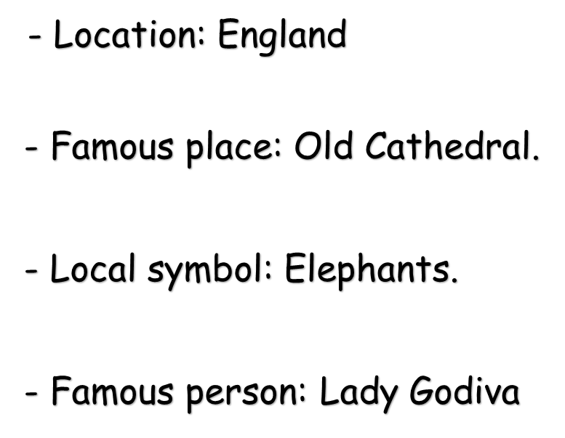
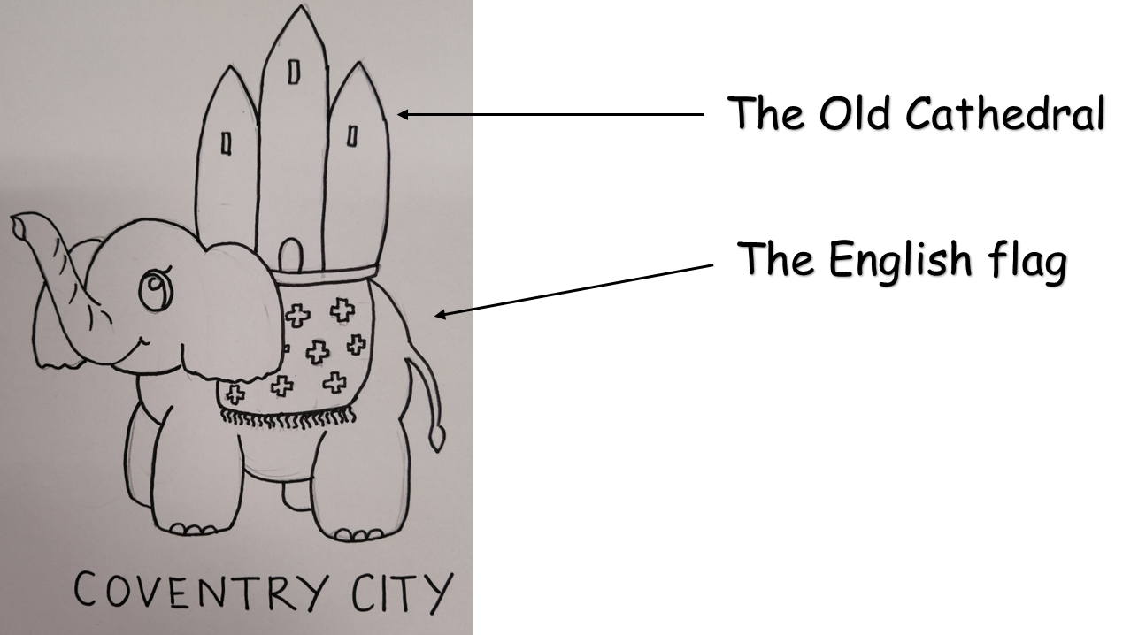
- Beginning with an example presentation introducing an original mascot for the ALT’s home country, the teacher gives the students a foreign city to research and make notes on its culture and popular tourist sites, etc, which could be used as inspiration for the features of their original mascot.

Lesson 1
- Firstly, the ALT introduces their original mascot using familiar or useful sentence structures that the students can refer to when writing the script for their own presentations.
  - The target length of the presentation and any target content should be made clear at this stage.
- It is also useful to leave a slide up with the ALT’s speech on it if the students’ English level is low. The teacher gives the students a worksheet.

  - Worksheets should have a space for note-taking, a section for a draft mascot with space for brief explanations of the mascot’s features, and a blank box for a draft speech; please refer to the sample under “Additional Information”.
- Students then draw a foreign city at random out of a hat. Each city should be from a different country if possible.
  - A different method of random selection can be applied.
- Students begin researching their cities and making notes.Teachers should provide support and encouragement while the students work. Students will most likely begin drafting their mascots in lesson 1 as well.
  - Japanese is perfectly OK for the note-making part of this project.
Lesson 2
- The aim of lesson 2 is for students to finalize their mascots, presentations, and scripts.
  - The ALT should help with any questions students have about grammar and pronunciation.
  - It can also be helpful for the students who finish earlier than the others to have them do a practice run with the ALT so that the ALT can give them feedback.
- Depending on how quickly the students finish their preparations, presentations could begin in lesson 2.
  - For this, evaluation sheets may be needed.
    - Evaluation should focus not just on the students’ English ability, but also on the effort they have put into their mascots and how much they have to rely on their scripts. Example evaluation criteria includes: pronunciation, content, the mascot itself, and memorisation.

Additional Information:
This lesson came about in an effort to engage the more reluctant learners at my school. Originally, the students would have been doing a speech on an existing mascot from a city in Japan, as suggested by the textbook, but the JTL came to me for ideas on how to increase the “fun”. The students in the classes this lesson was used for are on courses that focus on arts and crafts, so giving them the opportunity to be artistic alongside their language learning was the obvious choice.
Individual expression in language learning is important. Students will always want to put a little bit of themselves into what they do, so as ALTs, we need to be thinking of how each and every activity can be tweaked or expanded to give them the space for that.

