Let’s Make a Pet Shop!
Class Time: 45 minutes
Class Size: 15-25 students
Target Audience: ES – 1st grade
Objective: Within one class, students will learn the names of common household animals, plus a short conversation in English, and interact with each other in English to make their own pet shop.
目的：なじみのある動物の名前を学びペット屋での会話をすることができるようになる。

Materials: worksheets, animal flash cards (A4 size), small animal cards (small enough to fit inside the boxes on the worksheet), stuffed animals (if possible)
Procedure:
- Introduction - 5 minutes
- Teachers greet the students (i.e. Hello! How are you?) and present the class topic.
- Teachers give an example of the conversation they’ll be doing:
JTL/HRT (as a person seeking animals for their pet shop): Hello!
ALT (as animal provider): Hello!
JTL/HRT: [Animal], please!
ALT: Here you go!
JTL/HRT: Thank you!
- Building Blocks - 20 minutes
- Introduce the Animals - 5 minutes
  - Teachers use the Animal Flash Cards to practice the words with the students. These words are dog, cat, mouse, rabbit, monkey, snake, and hamster. The ALT says the animal name, and has them repeat after them for each. Practice each name twice.
  - Teachers run through the animals once more, focusing on any names which seemed difficult.
- Magic Word Game (Animal Practice) - 5 minutes
- The teachers draw a cloud on the board, and put one animal card in it. This is the “magic word.” Including the “magic word”, say the words on the board at random.
- When they hear a word, the students should repeat it. When the “magic word” is said, they clap instead of repeating the word.
- Introduce the Dialogue - 5 minutes
  - The teachers practice the dialogue from the example with the students. First, students repeat after the ALT, going through the dialogue line-by-line and writing it on the board. Using two colors of chalk works well to indicate who says what.
  - Second, the students take one of the roles in the dialogue. The ALT takes the other and, while pointing to the lines that the students say, practice the conversation. Swap roles afterwards.
- Dialogue Practice (Pass the Plushie) - 5 minutes
  - Teachers take two stuffed animals, of the types being practiced in the lesson. If those can’t be secured, then use two of the Animal Flash Cards.
  - Students pass them between themselves while seated in a snaking pattern, using the dialogue for the animal. The ALT watches one plushie/card, while the JTL/HRT supervises the other. Correct any mistakes as they happen, and offer encouragement.
- Main Activity (Let’s Make a Pet Shop!) - 17 minutes
- Procedure Details – Teachers pass out the Pet Shop worksheet and split the students in half (groups A and B). One half (A) will sit at their desks and hand out small animal cards to the other half (B). Students in group B should seek out one of each of all 7 kinds of animals. If there are more than 7 students in each group, split the stacks of cards between several students – for example, two students may both be handing out cats.
- Part 1: Group A -> Group B ) - 7 minutes
- Students in Group A stay seated. Students in Group B stand up and seek out animals, using the “[Animal], please!” dialogue, and bring them back to their seats. Do not glue them on yet.
- Transition - 3 minutes
- Teachers collect the remaining animal cards from Group A, and hand them out to Group B students. The roles will now switch.
- Part 2: Group B -> Group A - 7 minutes
  - Now, students in Group B assume the role of Group A in the last round, so Group A students can collect their animals.
- Reflection and Gluing - 3 minute
- While gluing their animals onto their worksheet, students should volunteer (in Japanese) their opinions of what they did well, or found difficult.
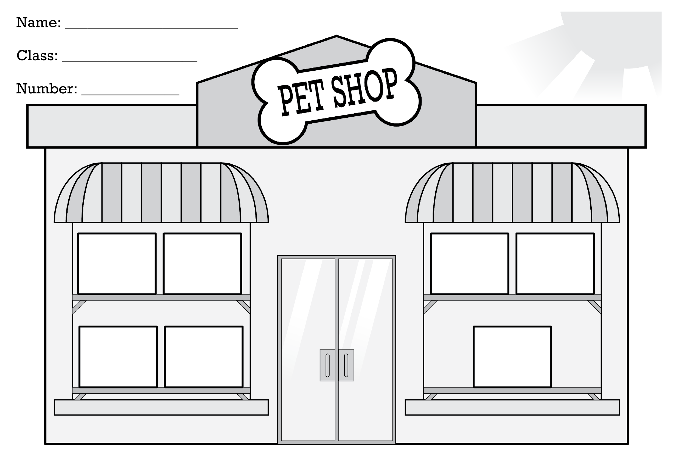

Some JTEs dislike having text on the board for younger classes. However, in the author’s personal experience, it helps to provide a textual representation of what the students are saying – not specifically for its value as text, but rather as a sort of diagram. The students may not be able to read, but writing text and pointing at it to indicate where students should be within a line, or which line in the dialogue they’re saying at the moment, helps the students pace themselves and speak smoothly with less confusion.

