Restaurant Conversation Practice
Class time needed for lesson: 50 minutes
Class size taught: Any class size
Target audience: SHS 1-3 grade
Objective: To encourage students to practice English speaking for everyday life situations used in daily life in English. Students will become comfortable ordering food at a restaurant.
目的：日常生活の場面で英語で話す練習をする。レストランで食べ物を注文することが抵抗なくできるようになる。
Materials: Printed worksheets, pens/pencils, plain piece of A4 paper for each student

Procedure:
- Greetings / Warm-up – 10 minutes
- ALT and JTL greet students and ask how they are today.
  - Ask questions such as, “how was your day today?”, “What did you have for lunch?”, “What is the date today?”, etc.
- Activity of listening for students.
  - The ALT will hand the students a piece of paper, then the ALT will instruct the students to draw a house on the blank worksheet in a step-by-step manner. The ALT will describe the house to the students as they draw it on the A4 piece of paper.
    - Example: First, draw a square, then draw a triangle above the square. At the bottom of the square in the middle, draw a small square, etc
  - After completing the house, the ALT shows the students the correct answer of the drawing on the board. Students get in pairs and exchange papers to see who listened to the instructions correctly.

- Main Activity – 30 minutes
- ALT and JTL hand students a worksheet of a dialogue between a waiter and a customer at a restaurant.
- JTL and ALT roleplay the dialogue on the script aloud as the model response to ordering food at a restaurant.
- Students memorize dialogue
  - JTL gets students into pairs and students practice the dialogue with each other.

  - Students change roles of being the customer and clerk respectively and memorize the script with and without the paper.
  - Students need to take turns memorizing being the clerk and then being the customer.

- Conclusion – 10 minutes
1. ALT and JTL select up to 8 pairs to role play the script in front of the classroom.
2. Alternatively, the ALT can have each student come outside the classroom to role play the dialogue with the ALT.

Additional information:
The ALT can give the students the scripts for homework in preparation for the conversation practice. Advanced students can be encouraged to ask additional questions such as, “Will you pay by cash or card?” “Are you eating in or will this be to go?”, “Will that be all?”, and “Sorry, that item is out of stock”.

Name: class:
Ordering food at a restaurant
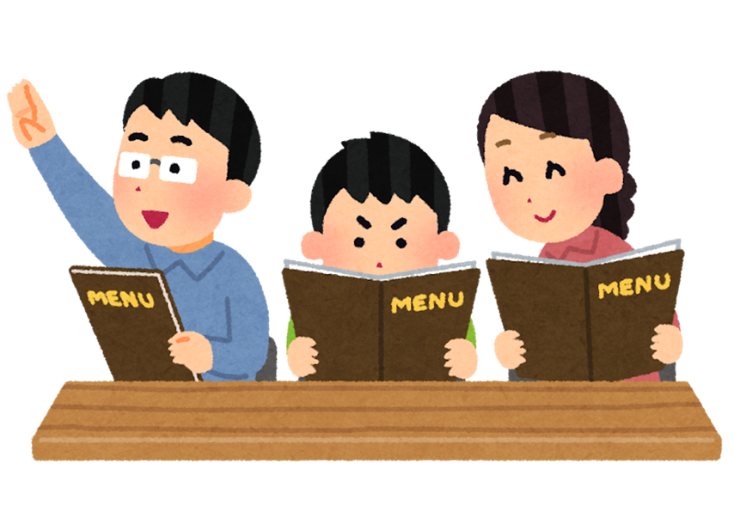
Waiter : Hello, what can I get you today?
Customer: What’s new on the menu?
Waiter: Well, we have the Tsukimi burger. It’s a new menu item that includes a cheeseburger Tsukimi set or Tsukimi Burger set. Will you eat here or take away?
Customer: Eat in please. On the menu what would you recommend?
Waiter: I recommend the cheese Tsukimi burger set with a Tsukimi Pie as dessert.
Customer: Okay sounds great
Waiter: What size drink and fries?
Customer: large on both please, I am very hungry today.
Waiter: Will that be all?
Customer: Can I also have a McFlurry on the side please.
Waiter: That would be twelve dollars and 50 cents please.
Customer: Here you are.
Waiter: Thank you. Your order will be ready in ten minutes

