Scrambled Lyrics
Class time needed for lesson: 50 minutes
Class size taught: 2+
Target audience: SHS
Objective: Students will improve their overall listening and writing skills through English songs and translation activities.

目的: 英語の歌や翻訳活動を通してリスニング力やライティング力を総合的に向上させる。
Materials: Worksheets, Japanese lyrics (cut-up), tablet/computer/mobile device, projector.
Procedure:
- Preparation - 5 minutes
  - After greetings, the ALT and JTL will begin the class by asking students to form pairs and discuss a topic related to music that can be as simple as: “Do you listen to any western or non-Japanese language music, and if so, what is your favourite?”, etc. Elicit student responses and guide discussion if possible.
- Pre Task - 5 minutes
  - The ALT and JTL will command the attention of the class and let them hear the song (English version) once before continuing onto the tasks. The teachers should also encourage note-taking and active listening.
  - After listening to the song, the JTL and ALT will assign students into groups and distribute the cut-up Japanese lyrics. To facilitate peer-teaching, the JTL and ALT should divide the lyrics into two halves and create an even number of groups.
- Main Task - 30 minutes
  - The ALT and JTL should ask students to begin translating their assigned half of the lyrics back into English and tell them to try to keep the lyrics as close as possible to what they heard earlier.
  - Once all groups complete their translations, the ALT and JTL should ask them to order their lyrics in a way in which they think makes sense.
  - To help, the ALT can play the song as many times as they believe is necessary for all groups to make corrections and rearrange their lyrics while actively listening. At the end of the activity, the ALT can display the Japanese lyrics and correct English lyrics on the projector for reference.
- Post Task - 10 minutes
  - The JTL and ALT can ask groups to come up with an interpretation of the lyrics of the song and encourage the students to think about any hidden story and/or meaning behind the lyrics. (Song choice is important).
  - Finally, the ALT and JTL will bring the groups together to combine each half of the lyrics so that the students can explain their view on the meaning. From there, the ALT and JTL can note any incorrect grammatical structures.

Additional information:
Main task/Post task flowchart
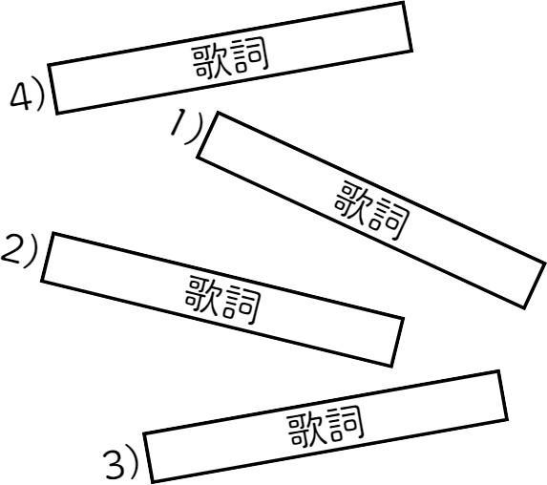

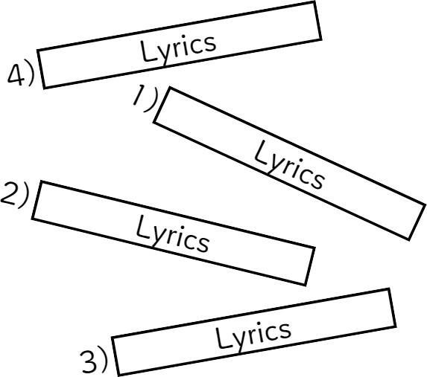


Post task (peer-instruction of grammar/content)
