Christmas Lesson
Class time needed for lesson: 50 minutes
Class size taught: 35
Target audience: Kindergarten
Objective: To learn about Christmas related vocabulary and have fun doing games and arts and crafts.
目的：楽しくゲームや図工などをしながらクリスマスに関する語彙を学ぶ。
Materials: Cards with pictures of vocabulary, variety of colored paper, scissors
Procedure:
- Introduction - 5 minutes
- The ALTwill greet the students.
- In Japanese, the ALT will ask the students about what their families do for Christmas.
- Vocabulary - 5 minutes
- The ALT will use flashcards with images of Christmas related vocabulary (with the vocabulary written in English and potentially hiragana).
  - For example: Reindeer, snowflake, sleigh, pinecone, Christmas tree, star, presents, candy cane, Santa Claus, snow man, etc. as desired.
  - If the students are having a difficult time with some of the vocabulary, reduce the number of vocabulary and remove the most difficult words.
- The ALT will read the vocabulary several times and have the students repeat the words back.
  - This part of the lesson might be the most boring part to the students, but it is essential to introduce the students to the vocabulary before starting other activities.
- Warm up - Jump Game - 5 minutes
- The ALT will hand out a flashcard with an image of one of the vocabulary words to each student making sure that at least 2 of each vocabulary flash card has been given.
- The ALT will then hold up a flashcard containing one of the vocabulary images and say the word out loud. The students holding a flashcard with the same vocabulary image on it will then stand up and jump.
  - The ALT will repeat this action until having gone through all of the vocabulary flashcards.
- The ALT will then repeat this game two or three times and can increase the difficulty by only saying the vocabulary word and not showing the flashcard with the image.
  - This game works well as a warm up before getting into other activities while still practicing the vocabulary.
- Touch the Flashcards - 10 to 15 minutes
- The ALT will take the same flashcards that were given out to the students and with the help of other teachers hang them up in random parts of the room at a level the students can reach.
  - There needs to be multiples of each flashcard as this makes it less chaotic with large groups of children.
  - If necessary, the ALT should separate the students into smaller groups to make it more manageable and less chaotic.
- The students will stand in the center of the room where they can see the flashcards hanging throughout the classroom.
- The ALT will then call out one of the vocabulary words.
- The students will run to the flashcard for that vocabulary word and touch it.
  - If it is too chaotic, have the students walk instead of running.
- After touching the flashcard, they will come back to the center of the room.
- The ALT should play this game as many times as needed for vocabulary practice.
  - For added difficulty, the ALT should try calling out several vocabulary words at once and have the students touch them in the correct order.
- Snowflake arts and crafts - Until end of class
- The ALT will hand out pieces of paper to the students. The papers can all be white or the students can choose which color they would like.
- The ALT will then demonstrate how to make the snowflake art.
  - The ALT will fold the paper into small triangles.
  - Depending on the age level of the students, less folds of the paper is easier for them to work with.
  - The ALT will then demonstrate cutting the triangle.
  - The ALT will then open their paper back up and show the students the now completed snowflake.
  - The students will then start to make their own snowflakes.
    - The teachers should go around the room and help the students with the folding and cutting.
    - If the students need help, the teachers can draw some simple patterns on the triangles for the kids to cut out.
  - Once the students have learned how to make the snowflakes, they can then use the leftover pieces of paper to make snowflakes of various sizes.
- Optional: The ALT or teachers can take all of the students' snowflakes and attach them to a string to hang up in the classroom as a Christmas decoration.
  - Make sure the students have written their name somewhere on the snowflake if they want to take it back at some point.
- Conclusion - 1 minute
- The ALT will thank the students and express how enjoyable it was and how amazing their snowflakes are.

Additional information:
When working with children at this age, the ALT needs to be as enthusiastic as possible and to never get upset at the children. When the children get too energetic and difficult to control, the primary kindergarten teachers will step in and help get things settled. When in doubt, it’s best to ask the primary kindergarten teachers for help.
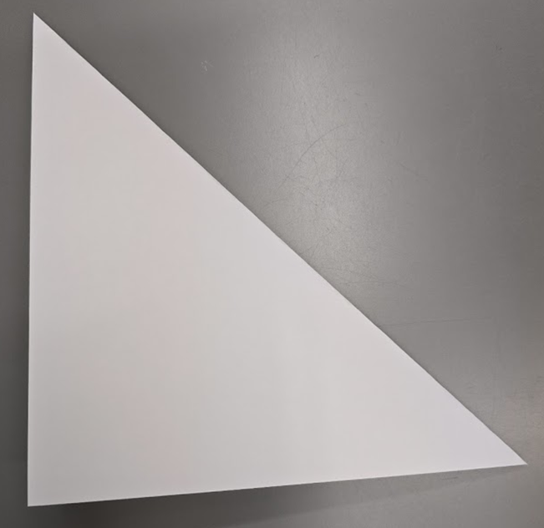
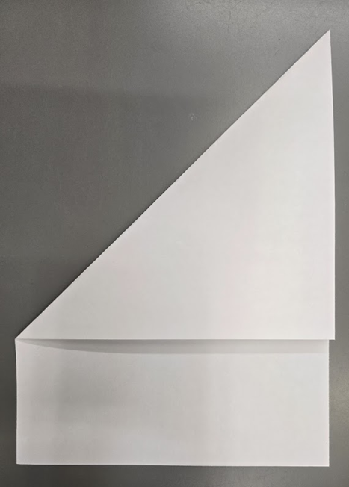
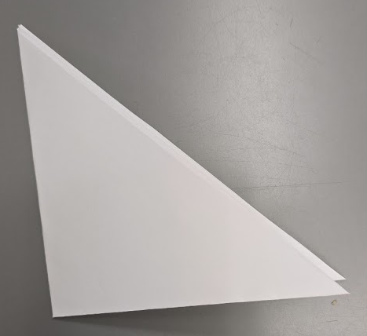
As the students are so young, the children respond best to activities that get them active. Sitting and repeating words over and over can make them restless and no longer care about the lesson. Some activities will take longer or shorter than expected due to how well the students take to the lesson. Every class is always different even when using the same activities. Remember to have fun! The more fun you have, the more fun the children have!

Step 1. Fold to make Triangle. 2. Fold in half. (Simple Version) Fold in half again.
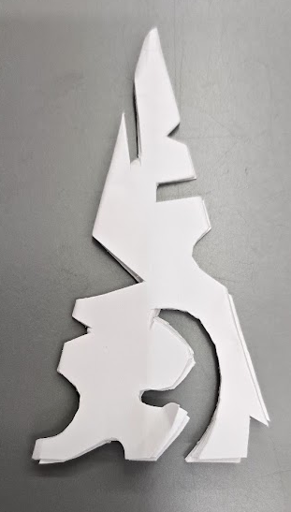
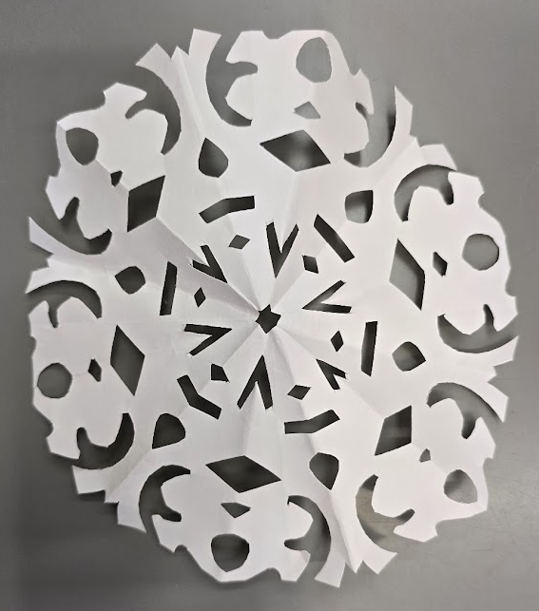
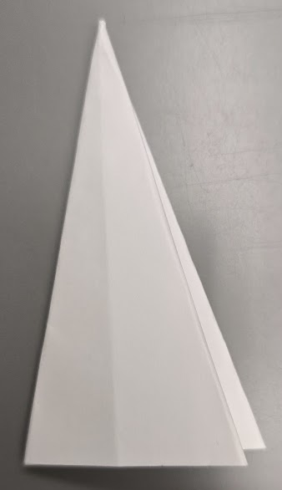
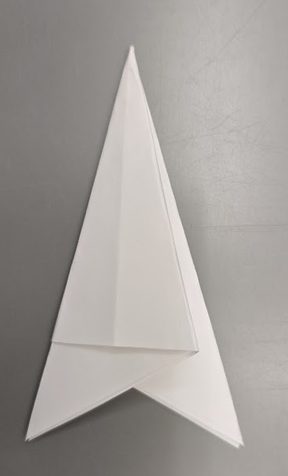
Cut off extra. Go to step 5.

3. Fold into thirds. 4. Cut off ears. 5. Cut design. Finished!

