Let’s Make a “Hand Turkey!”
Class time needed for lesson: 30-40 minutes
Class size taught: 20 students
Target audience: ES / 2nd~4th grade (This lesson was given to 2nd graders)
Objective: The students will be able to identify common Thanksgiving foods, make a common Thanksgiving craft, and understand Thanksgiving as a day of gratitude.
目的：感謝祭の一般的な食べ物を識別し、感謝祭の一般的な工芸品を作り、感謝祭が感謝の日であることを理解できるようになる。
Materials: Hand Turkey Worksheet, PowerPoint of Thanksgiving foods/traditions
Procedure:
- PowerPoint Presentation - 10 minutes
  - Teachers pass out Hand Turkey Worksheets. Students write their names on the top.
  - Teachers begin PowerPoint presentation. The PowerPoint should include slides to answer questions 1-2 on the worksheet.
    - Structure of the Powerpoint
      - Teachers briefly explain Thanksgiving as a holiday for gratitude (being thankful for what you already have, “giving thanks"). Teachers ask question 1 to the class, and write down common answers on the board with Japanese/English translations.
        - You can also talk about the Macy’s Thanksgiving Day Parade or the Superbowl if you wish.
      - Teachers explain that during Thanksgiving, families gather to eat special food. Give pictures and descriptions of common Thanksgiving foods (i.e. turkey, mashed potatoes, cranberry sauce, pumpkin pie) ask question 2 to the class, repeating student answers in English.
      - Include a drawing of a hand turkey on the last slide.
- Making a Hand Turkey - 20 minutes
  - Making a hand turkey: students trace their hands. The thumb becomes the face—eyes, beak, and the wattle. Below their palm is the feet, and the palm has wings. They can color the fingers as if they are feathers. Teachers should encourage adding accessories or things in the background.
    - Video: for extra time I showed a clip from A Charlie Brown Thanksgiving on YouTube. It had Snoopy carving a turkey with Woodstock, so there were no voiced lines. If you pick a different clip, be prepared to reflect with students on what was said.
Additional information:
Make sure you include Japanese translations for what is written on the PowerPoint, especially if you are doing the class without a JTL. If you have a JTL during class, they can help translate. Make sure the Thanksgiving foods are labeled with katakana.
I allowed students to answer the worksheet questions in katakana since 2nd grade hasn’t learned how to write the alphabet yet.
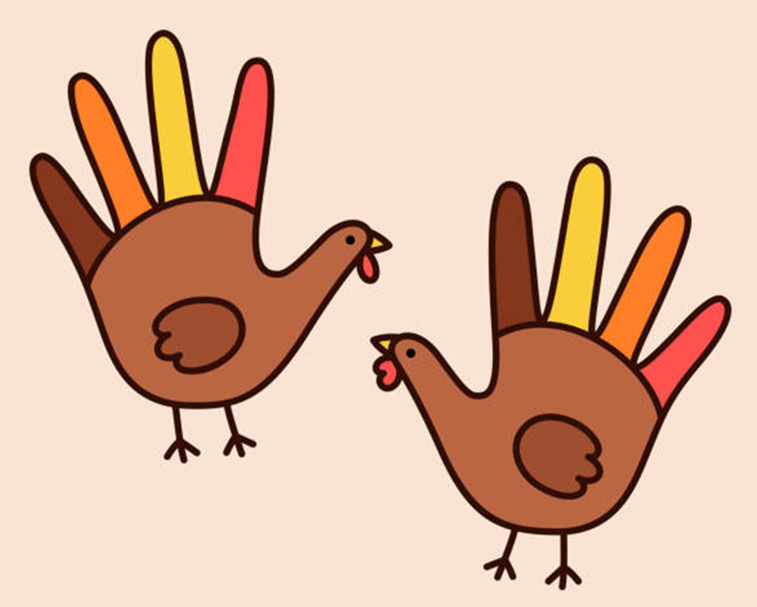
Hand Turkey example:

Sample worksheet:

Let’s make a “hand turkey”!
(「ハンドターキー」をつくりましょう！)

- I am thankful for ____________________________.
(は○○にしています。)

- A Thanksgiving food I would like to try is _____________________________________________.
(やってみたいのは○○です。)

