Lets Learn about the ALT’s School!
Class time needed for lesson: 50 minutes
Class size taught: 20-30 students
Target audience: 1st - 3rd Year JHS Students
Objective: To give students insight into the school system of the ALT’s country, to allow students to think about the differences between Japan and other countries
目的：ALTの国の学校制度を理解して、日本と外国の違いについて考えることができる。
Materials: Powerpoint “Choose Your Own Adventure” School Presentation
Procedure:
- Warm up - 10 minutes
  - The ALT will ask students whether they know anything about what schools are like in the ALT’s country. During the first few minutes of class, the ALT will provide cultural context for what their typical school system is like.
    - This can be done in a presentation format, or with short multiple-choice questions followed by explanations to make it more engaging. The ALT can ask questions like, when does school in America start? How do students get to school? etc.

- Main activity - 35 minutes
  - After the explanation, the ALT will open up the school presentation.
    - The presentation should be in the style of a “Choose Your Own Adventure” game, in which clicking on different prompts links to a specific slide (for example, “go to the cafeteria” or “go to the library” linking to their respective locations).
  - Using this method, students “tour” through the ALT’s school. The order in which the “tour” is conducted can be done by reading the options out loud and having students raise their hands, and choosing the majority winner.
    - The ALT will ask students, should we go [left] or [right]? etc.

- Conclusion - 5 minutes
  - Afterwards, the ALT will check understanding by asking students to comment on what they noticed during the presentation, and prompt students to think about the differences and similarities between the ALTs school and Japanese schools.

Additional Information:
This is a lesson that requires prep from the ALT beforehand. However, if needed, it can be adapted for different levels. For elementary school students, an adapted version could be used when students are learning about what students from other countries carry in their school bags (Lets Try 2 Lesson 4), the rooms in a school, or about life in Junior High School (Sunshine 6). Additionally, you could put more emphasis on specific grammar points or vocabulary such as asking for directions and direction words.

If the ALT is comfortable with showing and has pictures of the school that they attended, they can use their actual school, but otherwise, using stock pictures to give students the gist of a typical school works fine. The amount of English can be made easier or harder to adjust for different levels.

Optionally, the presentation can be made into a true “Choose Your Own Adventure” game by having options where students can interact with different parts of the environment or fictional student characters to achieve different endings (e.g. joining a certain club) to be made more engaging.

You can find videos online about how to make “Choose Your Own Adventure” slides on Google Slides or Powerpoint. For example, How to make a Choose Your Own Adventure Story (PowerPoint) and Choose Your Own Adventure Google Slides Template | CYOA Tutorial.

Example of Slides in Warm Up Presentation:
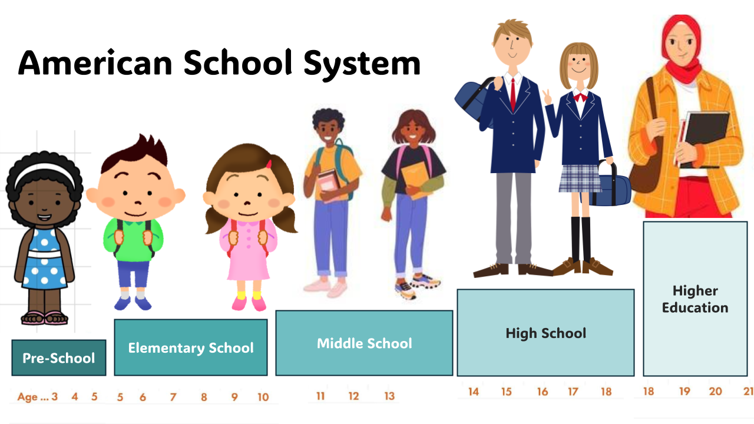
Examples of Slides:
