European Fact-Finding Mission
Class time needed for lesson: 25-30 minutes
Class size taught: 30-40
Target audience: SHS
Objective: Students will have to use their reading skills to be able to find specific information about various European countries written on posters.
目的：ポスターに書かれたさまざまなヨーロッパの国々に関する具体的な情報を通して読解力を向上させる。
Materials: Posters, worksheet and presentation (for instructions and answers).

Procedure:
Preparation:
Before the class starts, the ALT should make between 14-18 posters about different countries in Europe. On these posters, there will need to be some basic facts and other information such as population, capital city, languages spoken, etc as well. An example of a poster used is below. This will take time.

- Introduction – 5 minutes
- First, the ALT will start by introducing the activity. While this is happening, the JTL can start to put the posters around the room. Be sure the posters are spread out nicely.
- Next, the ALT will ask the students to make pairs or small groups depending on the size of the class.
- When the JTL has finished putting the posters around the room and students are in pairs, both the ALT and JTL will hand out the question worksheets.
- The ALT will then explain the worksheet and give the expectations for how the students should be answering the questions. They should show an example on the board.
- Main activity – 15 minutes
- Students will now stand up from their seats and move around the room in their groups of pairs and read the posters.
- To be able to answer the worksheets, the students must first read the posters and then write down the answers.
- The JTL and ALT should be walking around the room and guiding any students who are not able to find a country or are maybe confused with particular words written on the poster or question.
- The students will be given 15 minutes to try and get as many of the answers as possible. Once the time is up, the students will be instructed to come back to their seats.
- Conclusion – 5 ~ 10 minutes
- As the students are making their way back to their seats, the ALT will ask students to count how many countries they were able to complete. Any groups that finished can be given a reward.
- The ALT will then start going through the answers.
- The students will either say the answers as a class or the JTL and ALT can pick out groups or pairs to give their answers.

Additional information:
This activity can be done with any country from any continent. I initially chose Europe as it’s the continent I’m most familiar with, but I have done this activity with both The Americas and Africa as well.
The countries I chose were a mix of countries students are familiar with such as Spain and Germany, but also chose some countries they may never heard of before such as Andorra, Lichtenstein, San Marino and Malta. This way it makes them more aware of different countries and they learn rather than just making them more familiar with countries they already know.
The facts on the posters should be relatively simple to understand. Try not to repeat topics with multiple countries. Try to make them unique so the students won’t get confused.
When making the questions, make sure you include keywords from the posters. This way the students can find the answers more quickly and won’t get confused. The questions should make the students pay attention.
As a warm up you can include some things about culture. For example, I showed them a 5-minute video of my favourite Eurovision songs. This also gave me and the JTL more time to get the posters ready.
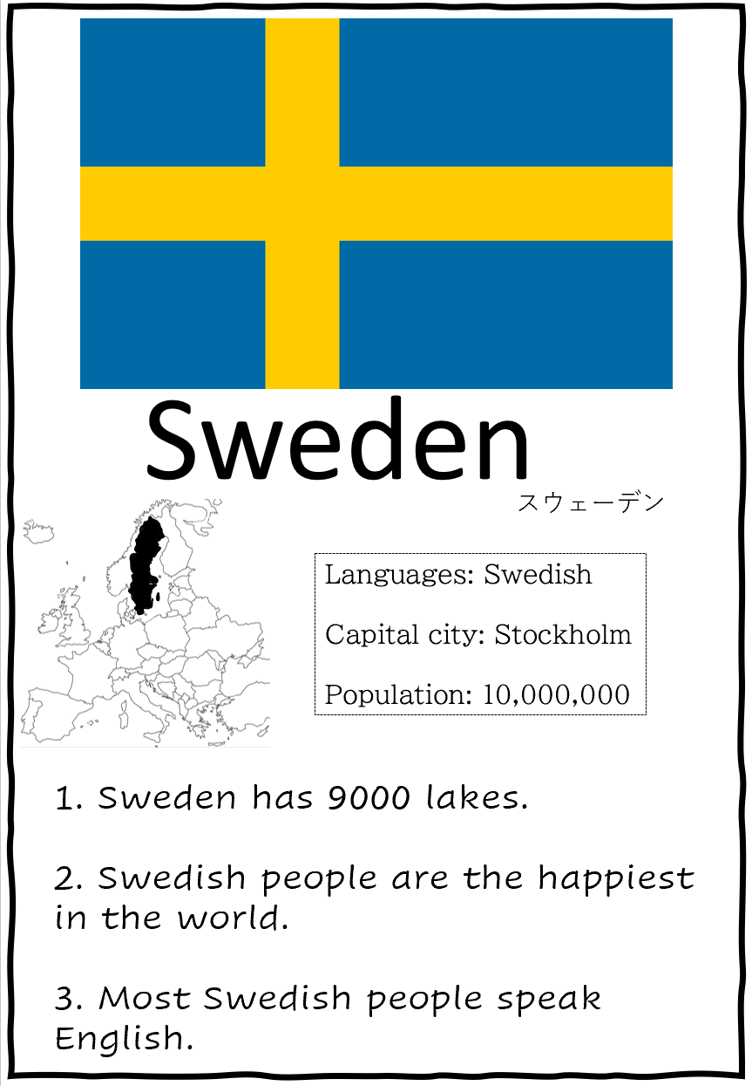
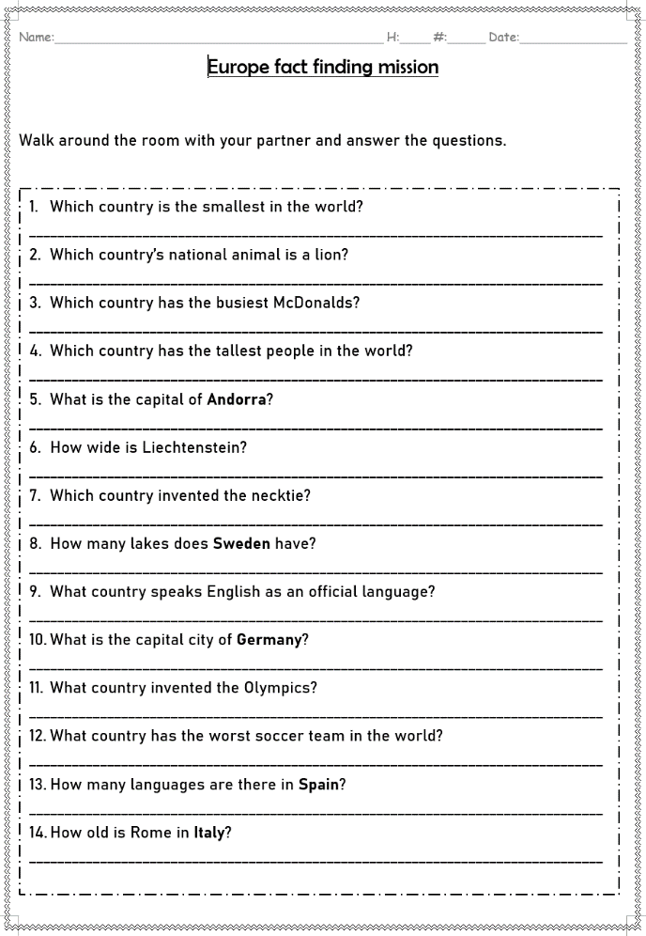
Here are the examples of the posters and the answer sheet:

For something extra. I also gave them a map to colour in the countries they read about. His was on the back of the answer sheet.
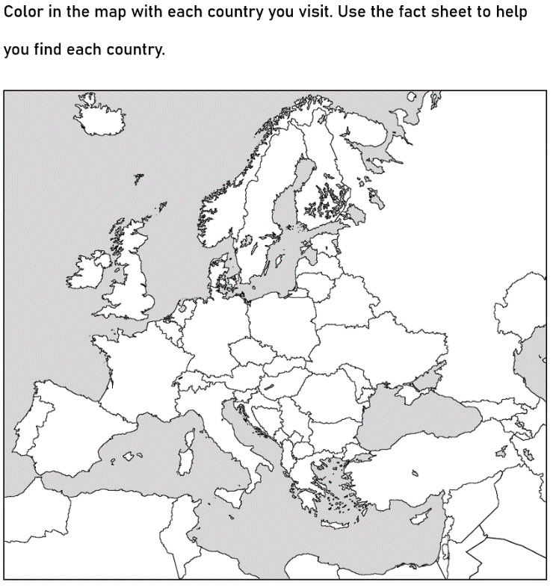
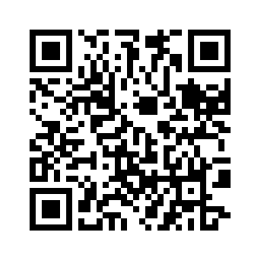
If you wish to use the posters I made. Here is a QR code to find them:

