Finding Similarities Between Cultures: Food Edition
Class time needed for lesson: 50 minutes
Class size taught: 10-15 students
Target audience: SHS
Objective: At the end of the class, the students will be able to determine the similarities between Filipino and Japanese food through a cultural worksheet.
目的：文化のワークシートを通して、フィリピンと日本の食べ物の似ている点を英語で表現することができるようになる。
Materials: Whiteboard, projector, laptop, tablets, whiteboard marker, and a worksheet provided by the ALT

Procedure:
- Introduction - 15 minutes
  - The teachers will begin the class by showing a picture of a Filipino food (e.g. siopao) and ask the students what they think it looks like. The students might say that it looks like a nikuman. The teachers will then say what it actually is.
  - The ALT will introduce the activity by explaining how similarities may be present across cultures, just like with food, and a brief history behind it. Then, proceed with the distribution of the worksheet.
- Main Activity - 30 minutes
  - The teachers will explain the worksheet to the class.
    - The students will look at a Filipino food in the first column, its characteristics in the second column, and put a Japanese food they think looks/tastes similar to it in the third column.
    - After writing their answers in the third column, the students will complete a sentence in the fourth column using some words from the second column.
      - I think (nikuman) looks similar to (siopao) because it’s also (white and soft.)
      - I think (nikuman) tastes similar to (siopao) because it’s also (savory and meaty.)
      - Additionally, the students may also write, I think (nikuman) looks similar to (siopao) because it also has (meat inside).
    - Once they have finished filling out the first part of the worksheet, the students will work in pairs and compare their answers by reading their sentences from the fourth column.
  - Afterward, the students will be asked to look at the back of their worksheets. They will rate each Filipino dish based on how much they would be willing to try it: five for the highest, one for the lowest.
- Closing Activity - 5 minutes
  - The teachers will commend the students for trying their best and ask them how they felt about the activity.

Additional Information:
This is a good way of introducing another culture to the students. It’s also interesting to find similarities rather than differences across cultures. But it’s also important to note that there will always be a distinct difference (a local ingredient, how it’s made/cooked, its history, etc.) that makes it special to that culture. You may also extend this to other topics such as superstitions, school rules, traditional games, or anything the students can relate to and compare with their own.

Feel free to change how the sentences are written in the fourth column of the worksheet depending on the English level of your students. You may also discuss a specific grammar point before having them do this. As for my students, we decided to just have them complete the sentences.

Sample Worksheet
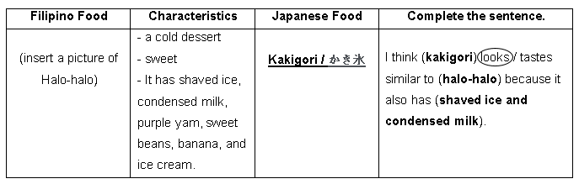
Front
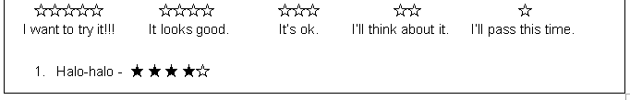
Back

