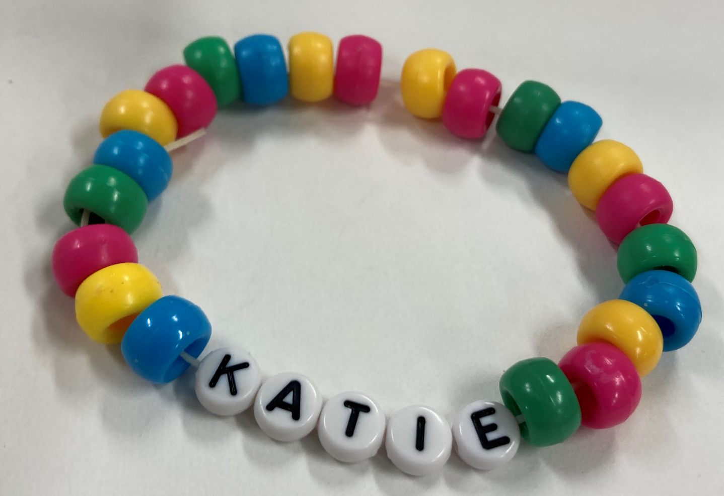
“My Name” Beaded Bracelet
Class time needed for lesson: 45-50 minutes
Class size taught: 20-30
Target audience: elementary school 3rd grade to 3rd grade junior high
Objective: Students will act as shoppers and shopkeepers, using shopping dialogue and the alphabet to make a bracelet with their name.
目的：交替してアルファベットビーズを売る人と買う人の役になりきり、買い物の時に使う英語表現を練習する。買ったビーズを組み合わせて自分の名前入りのブレスレットを作る。
Materials: alphabet beads, colorful beads, elastic string, small plastic bags, tape, scissors, signs or alphabet cards to indicate the shop

Procedure:
I. Preparation – 1 hour
- Teachers will prepare the romanized spelling of students' first names using Hebonshiki spelling.
- As well, teachers will sort the alphabet beads by letter and put them into small containers. Colorful beads can be mixed or separated by color, depending on personal preference.
- The teachers prepare signs to place in front of the shops designating what type of bead is at the “shop.”
- The teachers cut the elastic string in advance and place a piece of tape on one side so the beads don’t slide off when students thread them through.
- The teachers place the string with tape and the romanized spelling in a small clear bag. Students will later use this bag to place the beads they select and to double-check the English spelling of their name.
II. Main Activity - 5 to 10 minutes
- The teachers review the alphabet and practice shopping dialogue.
- The teachers separate students into two groups. Half will be shopkeepers and the other half will be customers.
- The teachers assign shopkeepers to a shop and start the first round.
- Students go to the “shops” to “buy” the letters for their name and any other colors they want to use for their bracelet. They will place the beads into the small clear bags.
- After about 7-10 minutes, the teachers switch the shopkeeper and customer roles.
- The teachers start the second round.
III. Conclusion and Feedback - 2 minutes
- Once students have selected all their beads, they can thread them through the elastic string.
- When they are done, teachers will help them tie their bracelet and cut any excess string. Tie the elastic 3-4 times tightly.
- The teachers give positive feedback on their performance, highlighting specifics.

Additional information:
Alphabet beads can be difficult to find in-stores in large packs, so it may be better to order online. Because this activity is expensive, it is recommended to do this for an English summer camp where the BoE sponsors the cost. However, if an ALT’s school gives permission and covers the costs, it can be a fun activity for regular English class.

An adult needs about 25-30 beads for a bracelet. Students will need less depending on the size of the wrist. Give the students an estimate for how many beads they should collect before starting the shopping game. It’s easier to take beads away than to add them.

