Passive Sentence Race
Class Time: 30 minutes
Class Size: ~35 students
Target Audience: JHS 2nd grade
Objective: During a 50 minute class session, students will have practiced recognizing passive and active voices by working together to rearrange sentences.
目的：受動態と能動態を理解し、受身形から能動形の文へ、能動形から受身形の文へ書き換える練習をする。
Materials: Textbooks Sunshine 2 Program 6, worksheet, sentences paper slips, characters (optional)

Procedure:
- Review - 5 minutes
- JTL reviews active and passive sentences.
  - Be sure to go over what makes a passive sentence and do some practice on recognizing passive vs active sentences.
  - Optional: You may want to start with a review worksheet, where the teacher gives students sentences and they circle A for Active or P for Passive. The teacher gives them about 3 mins to complete and about 2 mins to check and for the JTL to quickly go over answers.
- Rules Explanation and Game Play - 20 minutes
  - The teacher makes groups and each group chooses a character.
  - The teacher draws a racetrack with 9 tick marks between the start and finish line and places characters at START.
  - The teacher passes out a worksheet to all students in the group. This will help ensure that all students are participating in some way.
  - There are 10 sentences in total, and groups are given either a passive or an active sentence, one at a time.
  - Groups must all copy down the sentence and circle A or P.
  - The group leader collects all the papers and brings them to the ALT and JTL to check. All group members need to have matching correct answers to be given the next sentence.
  - Each time a group completes a sentence, their character moves a tick forward. The first group to complete all 10 sentences and reach the FINISH line wins!

- Notes on roles:
  - Both the ALT and JTL will need to help check the papers and give out sentences. Each can take care of half of the class, or one teacher checks, while the other passes out new sentences.
  - For a more challenging activity, instead of copying sentences, the teacher can make them unscramble sentences.
  - Using a circle or double circle might be more recognizable to students, but tick marks may be used to introduce the differences for western grading marks.

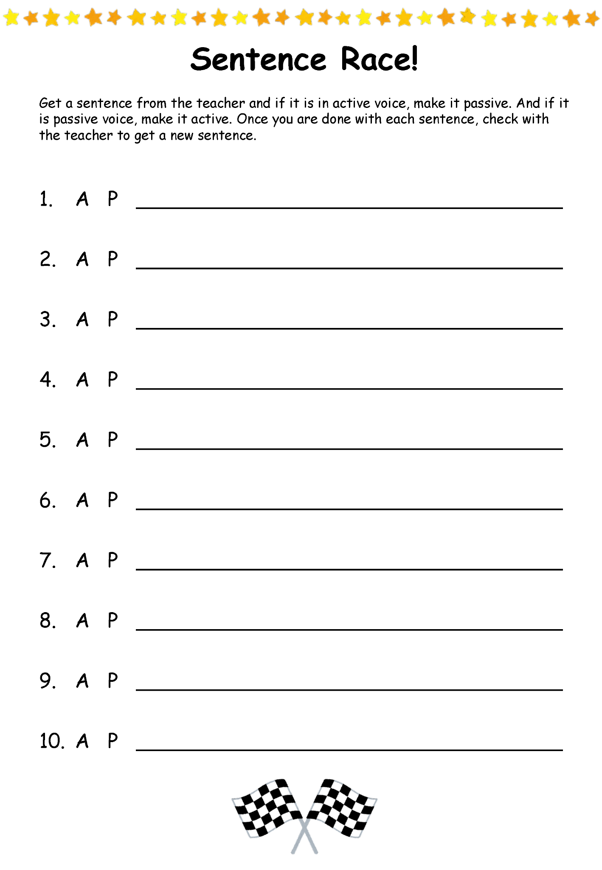
Additional Information:
