Exploring Music Around the World
Class time needed for lesson: 45 minutes
Class size taught: Any class size
Target audience: SHS, any Grade or Level
Objective: Within one class, students will be able to recognize different types of music from around the world, becoming more culturally aware and practicing very basic vocabulary and listening skills.
目的：世界中のさまざまな種類の音楽を認識し、文化的認識を高め、基本的な語彙力とリスニングスキルを向上させる。
Materials: Picture of world map or real globe, Music vocabulary flashcards, pictures of musical instruments from various cultures, whiteboard and markers, a computer device for playing music worksheet (one for each student)

Procedure:
- Introduction/Greeting - 5 minutes
  - The ALT and JTL will greet students and ask if they enjoy listening to music.
  - The ALT will show students a world map or globe and explain that the lesson plan will be about music from around different parts of the world.
  - The ALT will ask students if they know any famous musicians or types of music from different cultures. The JTL will write responses on the board.
e.g. Reggae - Bob Marley, Kpop - New Jeans, Rock - Beatles.
- Activity 1: Music Vocabulary - 5 minutes
  - The ALT introduces basic music vocabulary words .
    - For example, “music”, “song”, “singer”, “instrument”, etc.
    - The ALT may use flashcards to illustrate these words.
  - Students will practice pronunciation and understanding through repetition.
- Activity 2: Musical Instruments Around the World - 10 minutes
  - The ALT will show pictures of various musical instruments from different cultures.
    - For example, Kalimba, Maracas, Shamisen.
  - The ALT will ask students to guess the name of these instruments. The JTL will write the correct names on the board.
  - Students and the ALT/JTL will have a short discussion about these instruments.

    - E.g. “What do you think this instrument is made of?” or “How do you think it sounds?”
- Activity 3: Listen and Match - 10 minutes
  - Students will be placed into pairs or groups, and in these, they will each receive a pack of six country names.
  - The ALT will play short audio clips from different countries.
    - e.g. Japanese traditional music, Brazilian samba, Indian sitar music.
  - Students will listen to the music and in groups decide which country the music is from.
  - The JTL will count the students down (20 seconds), and the students have to hold up the correct country.
    - Correct answers get a point (Points are written on the board by the JTL).
- Activity 4: Musical Genre Karuta - 10 minutes
  - In the same groups, students will be given a pack of cards of 9 music genres. The pack must be laid down in front of students so all students can see the cards.
  - The ALT will play a variety of music snippets from different genres. When students hear a genre, they have to race in their group/pair to be the first one to pick up the correct answer and raise their hand.
  - The student who guesses the most correct number of genres wins.
- Conclusion
  - The ALT and JTL review what students have learned about music from around the world.
  - The ALT asks students to discuss in pairs one interesting thing they learned during the lesson.
    - The ALT and JTL encourage students to explore more world music on their own.

Additional Information:
For flashcards and vocabulary sheets, decide on what words to use depending on your own students’ ability. My students work on a stamp and reward system, so many of those count to a prize. I also introduce Eurovision at the end of the lesson as a great place for them to listen to global music.
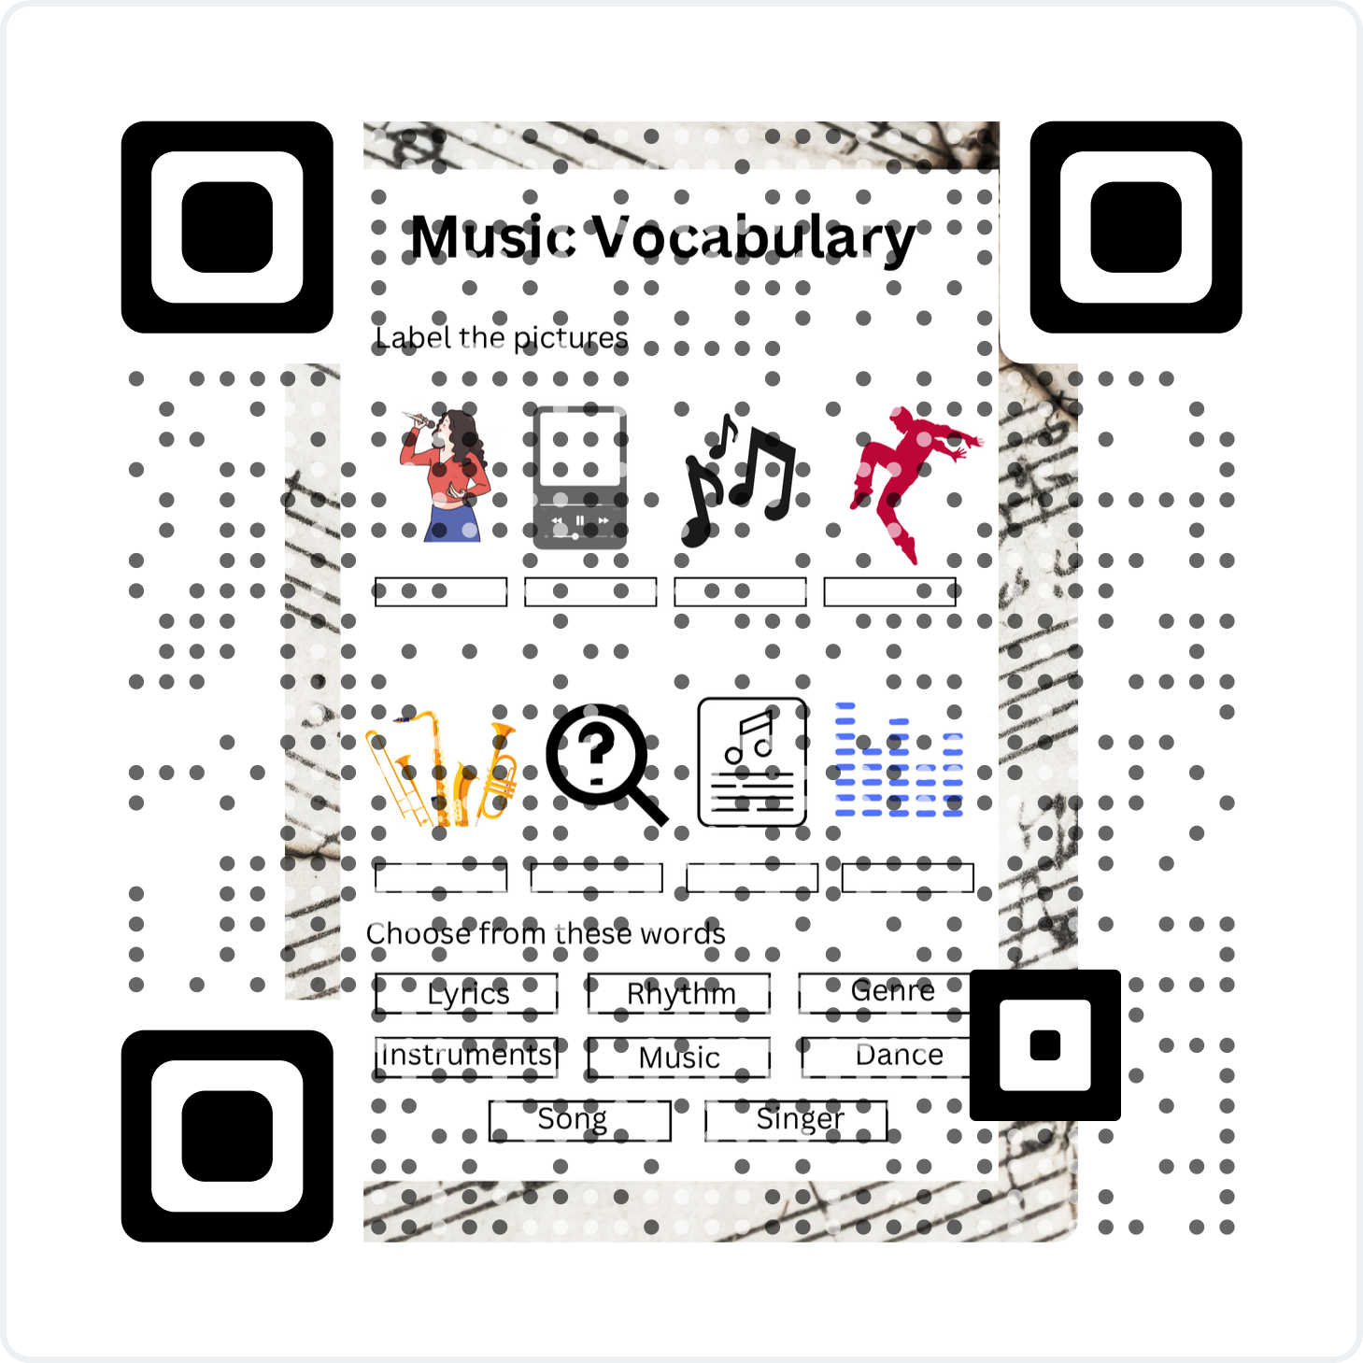
Worksheet is available through this QR code:

