Let’s Go Monster Hunting
Class time needed for lesson: 35-45 minutes
Class size taught: 30-40, any size
Target audience: ES 6th, JHS, HS
Objective: Students will use their knowledge of English to ask and answer questions about a Halloween-themed character’s physical features and abilities.
目的：英語の知識を使って、ハロウィンにちなんだキャラクターの特徴や能力について質問したり答えたりすることができるようになる。
Materials: Worksheet (see procedure for details), small laminated cards with pictures of various monsters on them, images of monsters to be shown on the blackboard (i.e. using a projector or a large poster)

Procedure:
- Introduction - 3 minutes
  - The teachers will introduce the activity to the students and explain the rules (more information below).
- Preparation - 5 minutes
  - The students will receive the materials they will use to play the game. These include:
    - A worksheet which contains pictures of the monsters that will appear in the game, a section for them to calculate points earned in the game, and, if necessary, examples of words and expressions they can use during the game.
    - A small card with a picture of the monster that student will be playing as. Students must keep this card a secret from other students.
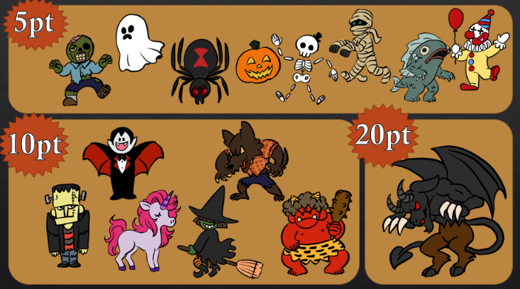
  - The teachers will present full-body images of the monsters on the blackboard so that the monsters’ features can be more easily seen by the students. E.g.:

    - This time should be taken to teach or review the monster’s names in English if necessary.
- Activity - 30 minutes
  - The students will walk around the classroom and talk to each other with the goal of figuring out which monster each other is through the process of elimination.
    - Students must ask each other questions about their monster’s physical characteristics or abilities, e.g. “Do you have green skin?” “Can you fly?” etc.
    - They should avoid directly asking what monster their partner is, e.g. “Are you a zombie?”
    - Students will take turns asking these questions.
    - When answering questions, students can say “yes’’ or “no”, but it is also acceptable for them to give in-between answers such as “maybe” or give hints when their partner’s guesses are close (e.g. “Are you green?” “Close. I’m blue-green.”)
  - When a student correctly guesses which monster their partner is, they mark that they have found that monster on their worksheet with a check mark, tally, etc.
  - Once they have both figured out each other’s identity, students can move on to another conversation partner.
  - Each monster is worth a certain amount of points. As they talk to one another, students will keep track of how many of each monster they have encountered.
- Conclusion - 5 minutes
  - The students will add up the point values of all of the monsters they have found and write it down on the worksheet.
  - The teachers will collect the worksheets to check the students’ total points and distribute rewards at a later date if desired.

Additional information:
If you are familiar with the board game Guess Who, this is essentially the same thing. This game can be adapted for higher grade levels using more complicated English expressions. This activity works the best if the teachers offer rewards as incentive for the students to participate, for example giving them stickers or other prizes if they reach a certain number of points or if they can find a specific monster (e.g. the Jersey Devil as shown on the sample poster). The word bank shown on the sample worksheet may not be necessary for high-level classes. The teachers can also participate in the game as conversation partners with high point-value monsters, so that students can be further rewarded for conversing with the teachers.

