MBT-Island
Class time needed for lesson: two 45-minute lessons
Class size taught: 30 students
Target audience: SHS 2nd grade, but can be adopted to other levels
Objective: In the span of 2 classes, students will be able to compare statistical averages between micro and macro data by comparing Japan’s Personality statistics with the class. Then, students will discuss the intricacies of their personality type alongside people with similar personalities through a simple thought experiment.
目的：日本の個人性統計をクラスと比較することで、マイクロデータとマクロデータの統計平均を比較することができるようになる。また、単純な思考実験を通じて自分の性格タイプの複雑さについて、似たような性格を持つ人々と英語で議論できるようになる。
Materials: MBTI PPT/Canva Presentation, 16 Personalities Worksheet, 16 Personalities Test, MBT-Island Presentation, Enrich Learning English Communication II textbook.

Procedure:
CLASS #1
- Before The Class
  - The students will be asked by the teacher to finish the personality test found on the website www.16personalities.com and collect their findings and have it ready and prepared for the class.
    - The test takes approximately 5-10min to finish, so if students haven’t done it before the class starts, allow them to quickly do it during the warm up.
- Vocabulary Warm Up - Approx 8-10 Minutes
  - The teacher will give the students 4 minutes to brainstorm words that they associate with “personality”.
    - As long as they can justify the word and understand its meaning, any appropriate word is allowed.
    - Depending on the classroom dynamic, a maximum of 2 minutes can be provided for extra time.
  - After 4 minutes, the ALT then chooses a random line, either a row or a column, of students to begin the activity. This warm up is similar to a game reiteration of Tate/Yoko.
    - The students in the chosen row or column will stand up. After the count of three from the ALT, students will raise their hand if they have a word related to “Personality.”

      - If a student is able to provide a word, they are able to sit down. The last person in the aforementioned line indicates the next line that will stand up, opposite of what was chosen prior. I.E. If a row was selected prior, the column of the last person to sit down will stand up.
      - This can be done as many times as desired.
      - The ALT or JTL will write the words up on the board.
- Personality Presentation - 25-30 minutes
  - Handout
    - The JTL and ALT will distribute a two-sided handout to the students. The first page will be for the first class.
    - Student’s are then encouraged to write their own Myers Briggs Results onto the section: “My personality is…”
  - Active Presentation - 25 minutes
    - The ALT will briefly describe the Myers Briggs Personality test: what it does, who it’s for, and what it indicates.
      - This is located in Page 4 of the MBTI Presentation.
    - Afterwards, the ALT will discuss the average personality report of Japan. The ALT will break down the average percentages found in the different personalities in Japan. Students will record these percentages on their worksheet under the section “Japan’s Average Personality.”
      - Found in Page 5 of the MBTIPresentation.
    - The ALT will then introduce the class to the ALT’s own personality type.
      - It is best if the ALT uses the same test used by students.
    - The ALT will then ask the students to stand up. After each slide, the ALT will describe traits for the following dichotomies: Extraversion (E) or Introversion (I), Sensing (S) or Intuition (N),Thinking (T) or Feeling (F), and Judging (J) or Perceiving (P).
      - The ALT will allocate two sides of the class to be either end of a dichotomy. Students will then move to their corresponding side in relation to their personality results.
      - After each movement, students will count the members of their respective group and determine the percentile of students that fall into that respective side of the dichotomy.
      - This is done 4 times for each dichotomy.
    - After all 4 are done, students will write a small report comparing the class average personality type vs that of Japan’s average personality type.

- Cool Down Activity- 5 min
  - Preparation for the Following Class
    - The teacher will have the class find other students that have the same personality type as them and make a group. These students will then talk amongst themselves about their personality.
      - These personality types will be their respective groups for the following activity.
      - Some students will not have a group depending on the rarity of their personality type. That will be okay due to the nature of the thought experiment. These students can partner with other solo students as well.
CLASS #2
- Personality Warm Up - Approx. 8-10 min
  - Students will move to their personality groups that were established in last week's class. In these groups, they will do research on their personality strengths and weaknesses, as well as the potential career options that are best for their personality type.
    - If students are alone due to their personality being unique to the class, that is okay. Have them still go through the exercise as follows: listing their strengths, weaknesses, career options, etc.
  - Students will then pick what they believe is their best strength, their lowest weakness, and their best career option to present to the class.
- Thought Experiment MBT-Island - Approx 15-20 min
  - Students will remain in their groups and will be presented a scenario. The scenarios will be similar for every single group, and groups will work together to create a plan.
    - If the groups are small due to a rare MBTI typing, have the rarer personality types form one single group.
    - The scenario will be put on the screen for everyone to see.
  - The scenario used in this example is that of a deserted island; Students have been shipwrecked on this island and they are the only survivors. From the wreckage, they are able to salvage 10 items.
    - The item list that is provided can be very fundamental or very unique. A mixture of fundamental survival equipment and odd items can best showcase the differences between personality types.
  - In their groups, the students will determine the importance of each item, ranking the item from 1-10, 1 being the most important and 10 being the least. The students will have the span of 15-20 minutes to deliberate a consensus.
  - The students will then give a debrief of their item rankings.
    - Encourage creativity with the way they choose their items by explaining the ALTs own take on how to use them.
    - Please refer to “Additional Information” for the following worksheets.

- Group Presentation - Approx 10-15 min
  - Students will come up to the front in their MBTI groups. They will state their MBTI personality and then explain which items they will use to survive the scenario.
    - For example: “As an INTJ, we would use the paper clip for this reason.”
    - The ALT or the JTL can move the cursor or find a way to indicate the items the groups are referring to so that students can follow along using a visual aid.
- Cool Down - 5 min
  - In the same groups as their presentation groups, students will reflect on the different choices that their classmates have made and why they may or may not be so.
    - They can allude to specific MBTI traits to best explain their reflections.
      - I.e. These students have an introverted personality type so maybe that is the reason behind…..

Additional Information:
The scenario isn’t set in stone, so you can reformat the scenario how you wish. You could make things very creative like creating an “isekai” scenario for your students or even make it so that they’re the last people in the city. The thought experiment is to see how different personality types would deliberate decisions if they were to be the only personality type in a given situation. Mixing groups with rare types can be interesting too, as it exemplifies the role of diversity in society.
This class was done with students at a slightly higher level and does not need any Japanese translation in class, but I believe that the lesson can be done in lower level classrooms as well.

The Presentations and Worksheets are Accessible through these QR codes: 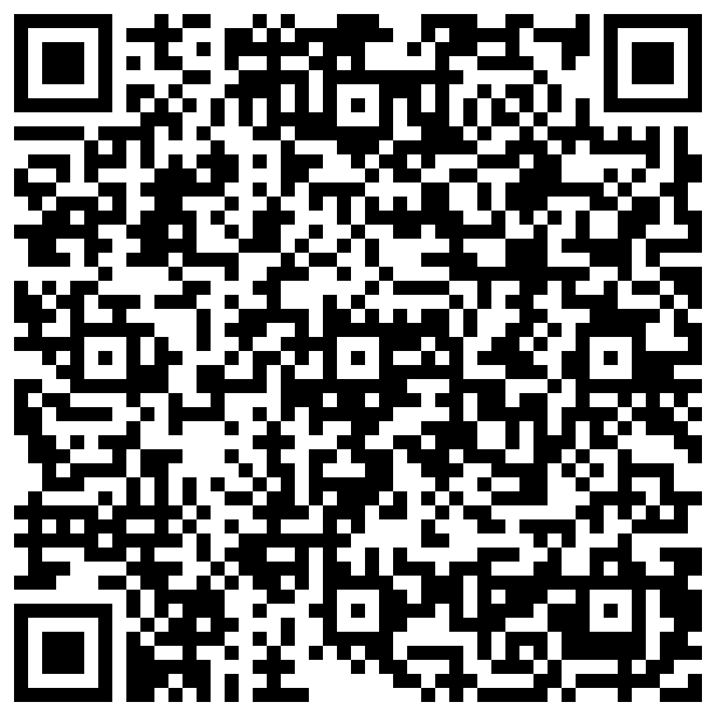 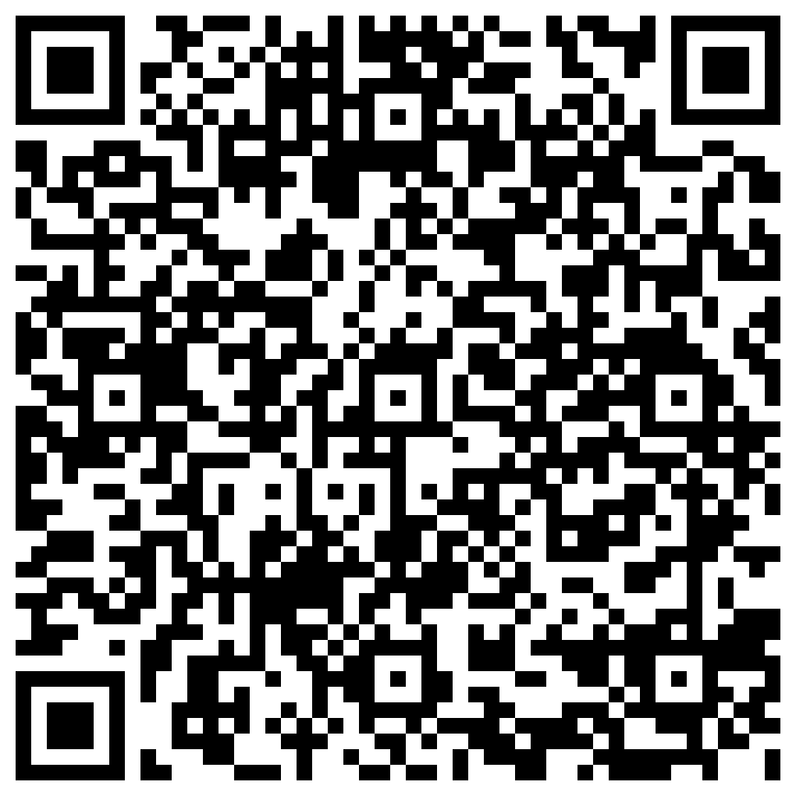 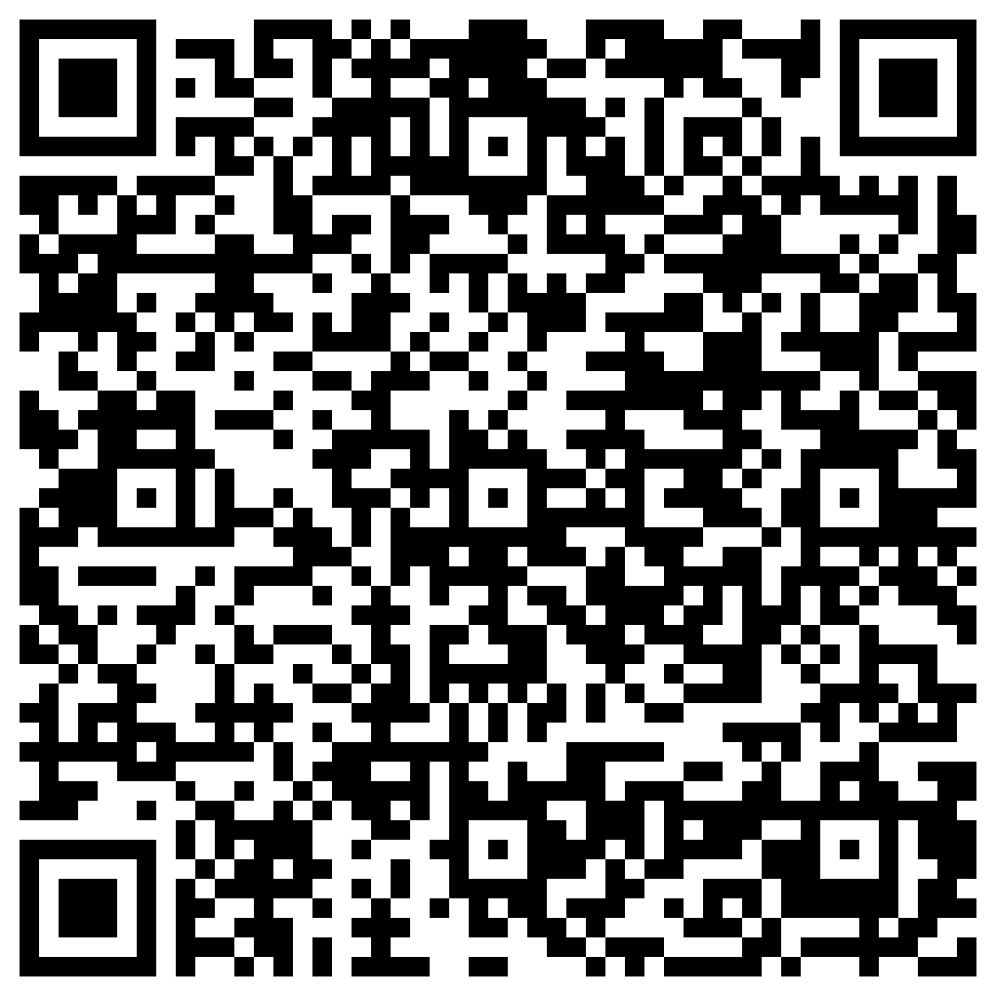
Myers-Briggs Presentation Activity Worksheets Lesson 2 Presentation

