Vocab Baseball
Class time needed for lesson: Up to 50 minutes
Class size taught: Any class size
Target audience: ES, JHS
Objective: Exercise spelling skills and vocabulary recall through a fun and interactive game.
目的：楽しくインタラクティブなゲームを通してスペリング力と語彙の想起力を鍛える。
Materials: Whiteboard and markers/blackboard and chalk, magnets

Procedure:
- Introduction – 5~10 minutes
  - This game is basically the same as the game “Hangman,” but remade in a more school appropriate theme.
  - Two “baseball fields” with areas to indicate the bases should be drawn on each end of the blackboard. A small section for “Outs” should be designated on the blackboard next to both fields, as well as a section for “Home runs”.
  - The JTL and ALT will divide the class into two teams and designate a student as team captain. More teams can be made, but two is ideal for this activity. The ALT can assign team names or allow each team to choose their team name. The ALT will then explain the rules of the game and demonstrate the game with a practice round.
- Main Activity – 30~45 minutes
  - Either the JTL or ALT will prepare a word or phrase for the students to guess by writing short lines corresponding to the number of letters in the word or phrase.
  - Team captains will do janken to determine which team guesses a letter first. Moving along the rows of students, each team will be allowed to make guesses until they guess incorrectly.
  - If a team guesses a letter correctly, the JTL or ALT will write the letter above the lines in all the positions that it appears in the word/phrase. A magnet will also be moved onto a base. The magnet will move however many bases as times the letter appears in the word/phrase. For example, if a team guesses “e” and that appears once in the word, the magnet moves one base. If “e” appears three times, the magnet moves three bases. If multiple magnets are already on the board, they all move bases along with the new one. Each magnet that passes the home base should be set aside to be counted at the end of the round or “inning”. Those are home runs and will be added to a team’s total score. Once this is done, the next student in the team will then make a guess.
  - If a team guesses incorrectly, the ALT will write the letter somewhere on the board so students know which letters have already been said. The team will also receive an “out”, and a magnet will be placed in the “Outs” section on the board. This will end the team’s turn and the other team will have a chance to guess. If a team receives three outs, they are no longer allowed to guess, and the other team will be able to make guesses until the word is either guessed correctly or they also receive three outs. If both teams strike out and the word has not been guessed, the outs and magnets on the fields reset and both teams are allowed to make guesses again.
  - A student who thinks they know the word/phrase may make a guess at any time as long as their team is not currently out. The student can raise their hand and guess the word/phrase regardless of which team’s turn it is. If they guess correctly, they get a home run and all magnets previously on the field move past home base. If the student guesses incorrectly, they receive an out and their team forfeits their turn. Once a word/phrase is guessed correctly, this is the end of an inning and all home runs are counted and applied to each teams’ scores
- Conclusion
  - Once the game is over, whichever team has the most “Home runs” wins.
  - Optional prizes may be given to the winning team.

Additional information:
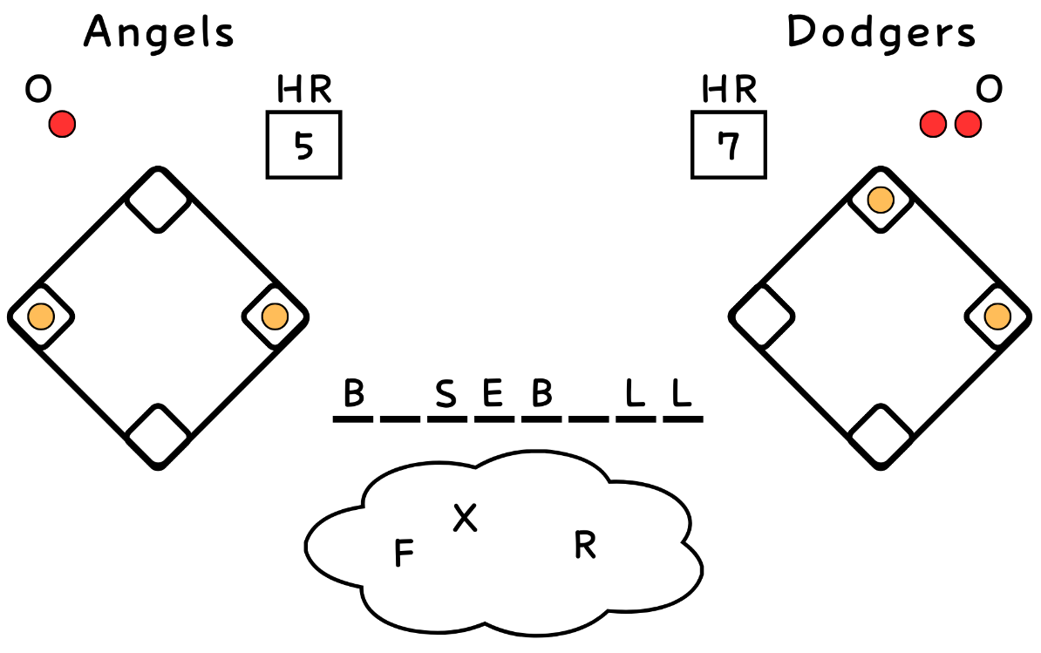
Below is an example of how the game can be set up on the board. The “fields” can either be drawn, or you can get fancy and make reusable fields out of paper and attach them to the board instead. This game is really good for days when you don’t have a lesson prepared or don’t have many students in the class.

