Big Numbers
Class Time: 50 minutes
Class Size: 30 - 40 students
Target Audience: SHS – 3rd grade
Objective: In one class, students will learn how to recognise and write big numbers.
目的：大きい数字を聞いて理解し、それを正しく書くことができるようになる。
Materials: Worksheets, use of a screen/blackboard, stickers for volunteers.

Procedure:
- Introduction - 20 minutes
- After the usual daily greetings (‘Good morning’, ‘How are you’, etc), the students will do a warm-up activity. Worksheets will be handed out, and at the top of these worksheets will be some sentences involving big numbers. The ALT and JTL will then break the students up into pairs.
- The big numbers themselves should appear as blank spaces, so that when the ALT reads out the sentences, the students are challenged with trying to write the correct number in the blank space.
  - Note: No practice of writing big numbers is required, as this is just to see what their ability is.
- When the ALT finishes reading the sentences aloud and after repeating them a few times, the students can compare their answers with their partner.
  - A good way to increase engagement would be to have volunteers come and write their answers on the blackboard (The ALT can bribe the students with stickers if they seem reluctant). Then, the ALT can check if the answers are correct and potentially explain where the students got confused.
- Main Activity - 25 minutes
- The importance of the comma - 5 minutes
  - The second part of the worksheet should include a box with commas inside it. The ALT will ask the students what the commas in the numbers equate to (1 = thousand, 2 = million, 3 = billion, etc), then show that there should always be three numbers that follow a comma.
  - After this, the blackboard – or a screen – can be used to show the students new big numbers that they have to try and read outloud. A good way to proceed would be to start small and get gradually bigr, with trickier number combinations (for example: 3,000,030,003).
  - Now, the students have a good understanding of how numbers work in English, so the ALT can test them again!
- Numbers Quiz - 10 minutes
- The third part of the worksheet will be a short quiz. Students will listen to big numbers that can be tricky to understand and attempt to write them correctly.
- It is a good idea to use numbers like 40 and 14 for this quiz so that the students are challenged with recognising the subtle differences between the two.
- When the quiz is finished, again, the ALT should have volunteers come and write their answers on the board.
- Quizzing each other - 5 minutes
- The students will then be tasked with creating their own big numbers quiz for their partner. On the back side of the worksheet is a split table, with space on one side for the students to create their own numbers quiz, and space on the other for them to write the answers to their partner’s quiz.
- Conclusion - 5 minutes
  - After the students are done quizzing each other, it can be fun to have volunteer ‘quiz masters’ come to the front and select a challenger to write the big number they read out (more sticker incentives may be necessary).

Additional Information:
Depending on how enthusiastic your students are, this activity may need to be stretched out between two classes. Students may be more willing to participate when there is quizzing involved, and particularly with the last part - where they create their own quiz for their partners - a lot of shenanigans can ensue.
I created this activity after my JTL told me he wanted big numbers to appear on the listening test. The problem with big numbers is the way numbers are handled in Japanese is different from English, so the students get confused about how many zeroes are supposed to go where and such. After this activity, however, my students displayed a very strong understanding of how numbers work in English.

Below are samples from the worksheet I’ve used for your reference.

Sample 1
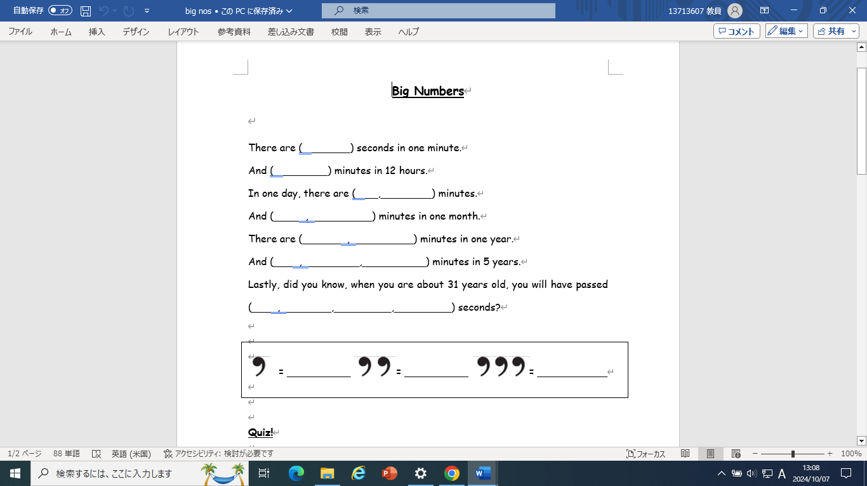
Part 1: Sentence reading.

Sample 2
Part 2: Commas.

Sample 3 Sample 4
Part 3: Tricky numbers quiz Part 4: Quizzing each other.
