What Time Is It? Four Corners
Class time needed for lesson: 50 minutes
Class size taught: 7-19 students
Target audience: 4th grade ES students
Objective: To practice counting from 1-12, learning the different events corresponding to the different times of the day from Let’s Try 2, Unit 4 “What time is it?”.
目的：１から１２までの数え方を習い、さまざまな時間を英語で言えるようになる。
Materials: name cards for Let’s Try 2 Unit 4 eg. “Wake-up time”, “Breakfast time”; four sheets of paper labeled “1:00-3:00”, “4:00-6:00”, “7:00-9:00”, and “10:00-12:00”; a timer

Procedure:
I. Review Preparation - 30 mins
- The ALT will start by having the students review counting from 1-12
  - The ALT will begin counting and the students will either echo or count along with the ALT
- Students will review the different events throughout the day utilizing the name cards.
  - Have the name cards in a place where the students can see them.
- The ALT and students Practice sample dialogues.
- Eg. What time is it? It’s 6 am it’s wake-up time
- Set up for the game by putting the paper with the time slots in all four corners of the classroom.
II. Introduction - 2 mins
- The ALT will explain the rules of the game to the students.
  - The students begin by asking the ALT “what time is it?”
  - The ALT will then say an event, and the students will have to find the corner within the time frame that matches the event
    - The ALT will say “it is _____ time” or “it is not _____ time” which students go to a corner that doesn’t match the time
- The ALT will demonstrate the rules of the game with the JTL/HRT.
  - JTL/HRT: What time is it?
ALT: It’s lunch time!
JTL/HRT: (goes to the 10:00-12:00 corner).
ALT: What time is it?
JTL/HRT: It’s 12 pm, it’s lunch time.
ALT: Good job!
III. Main Activity - 15 mins
- The ALT will have the students stand up and as a whole, have them ask you “what time is it?”
- The ALT will say a random event and give the students 10 seconds for them to get into a corner.
  - You might need to repeat the event a couple more times, so gesture to the name cards on the board instead of translating it into Japanese
  - With each round, increase the difficulty of the questions
    - Eg. use not~ sentences, the events that the students are least familiar with; namely homework, study and dinner time
    - For the students who miss the question, have them sit down at their seat.
      - Don’t forget to encourage them to avoid self criticism
  - Towards the 8-9 min mark, finish up the last round and declare the remaining students as the winners
    - Restart the game if there are only 1 or 2 remaining students

Additional information:
Before review, you can preface that there will be a game at the end of class time and that the contents of the lesson are important for helping you win the game. This will make the game more effective and cause the students to pay attention during class.
The students might not get the time accurately but the main emphasis will be the students' identification of the events “it’s study time”.
Preparation is quite simple and you can use normal 8x11 printer papers to create the time slots for the game. With a class size of 15 students, you can probably play 2 games within the span of 15 mins
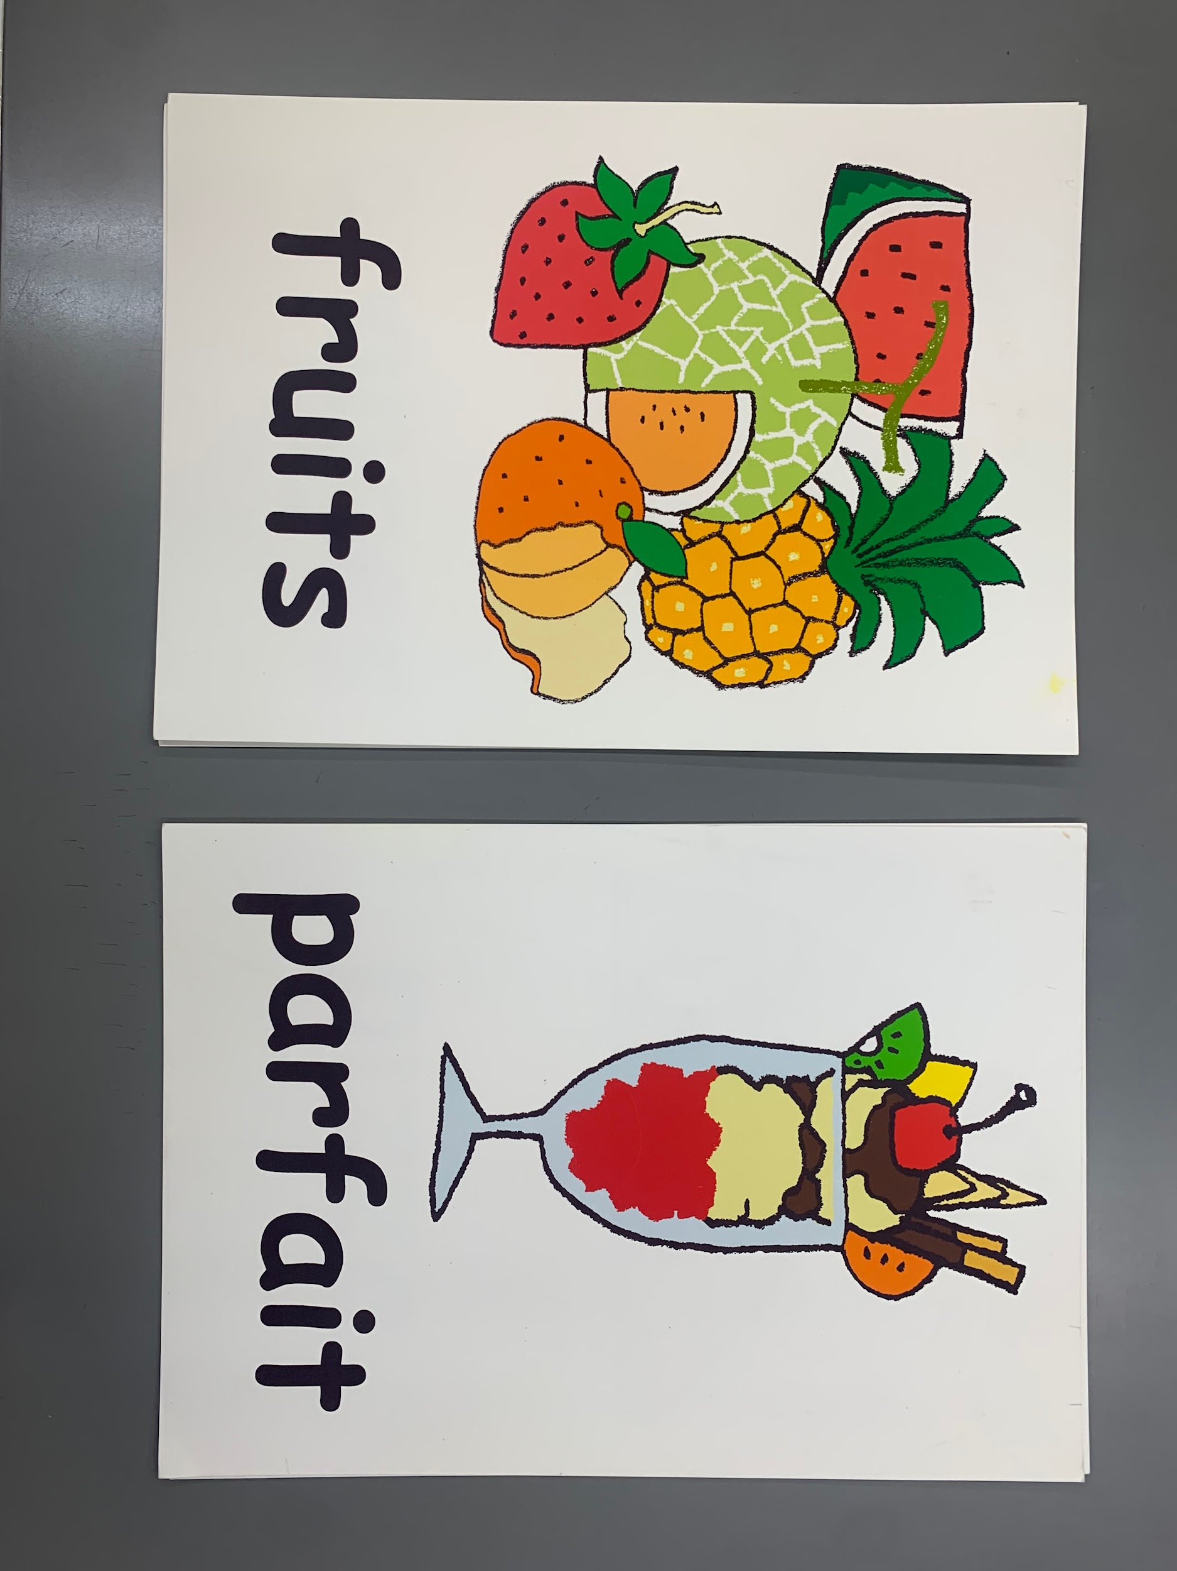 Name cards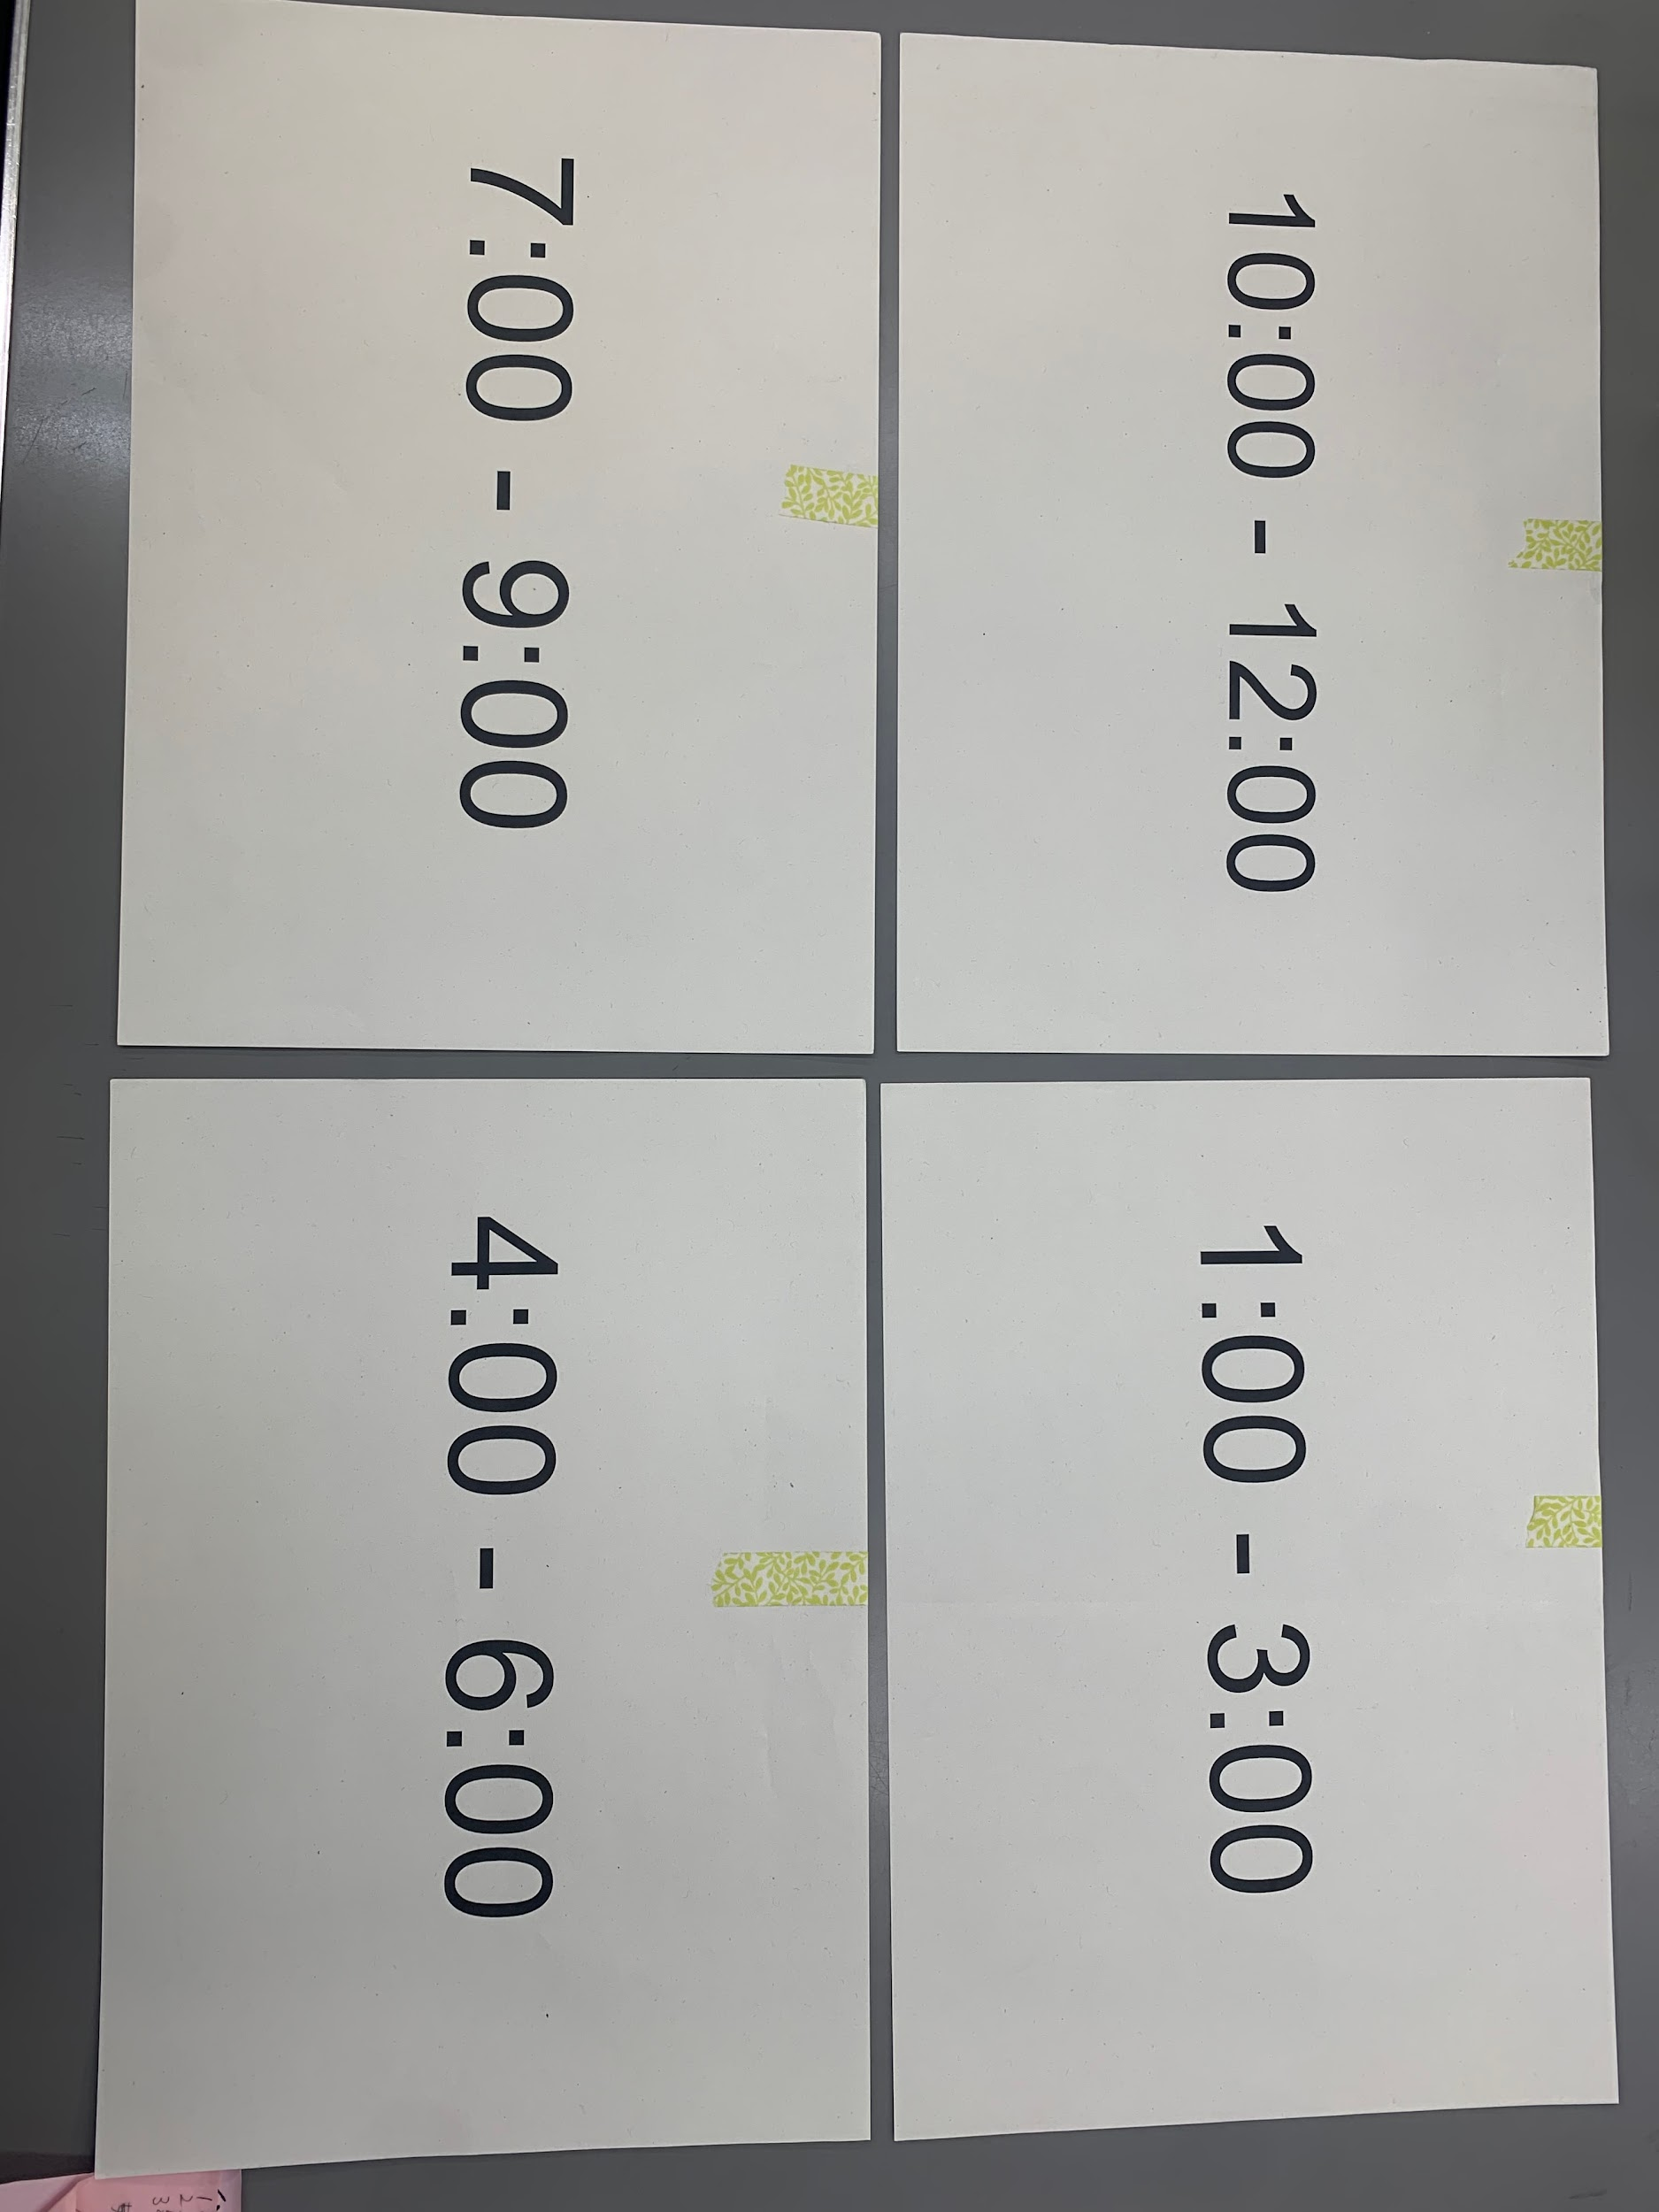 Papers for the time slot

