Self Introduction Board Game
Class time needed for lesson: 45-50 minutes
Class size taught: 2 students minimum
Target audience: ES 5 - SHS 3
Objective: Students will be able to review their grammar points from the textbook with a fun game that fosters healthy competition as well as English grammar retention.
目的：楽しいゲームで教科書の文法要点を復習し、英語の文法を定着させる。
Materials: Game board (1 for every group of 6 students), question cards, action cards, game pieces (students can use erasers instead if teacher prefers)
Procedure:
I. Introduction - 10 minutes
  - The ALT and JTE will do their usual greeting and questions before explaining the activity of the day.
  - The ALT or JTE will explain the Self Introduction game (explaining the cards and the different spaces on the board- see additional information for more details).
    - Students will need to get into groups (if class size is large enough). This can be done before introduction or after.

II. Self Introduction Game - 40 minutes
  - After all the materials have been handed out to each group, the groups of students will decide their order of turns. (This can be done with Rock Paper Scissors, Birthday Order, etc.)
  - The student whose turn it is will draw a question card. They read the question and then answer it in a full sentence. (Ex: When is your birthday? My birthday is _________.)
    - If the answer is a full sentence and correct, the student draws an action card and moves their piece that amount of spaces.
    - If it's a one word answer or incorrect grammar, the student can not draw an action card and it will become the next student`s turn.
    - If the student lands on a blue space, they can move ahead 2 spaces.
    - If the student lands on a red space, they move back 2 spaces.
    - If the student lands on a green exclamation point space then they move to the next green space that does not have an exclamation point.
  - Some action cards are special. (Ex: Move ahead 3 spaces with a friend, Go back to start, Send an opponent back 3 spaces, etc.)
III. Conclusion - 5 minutes (optional)
  - The HRT, JTE, or ALT may give out prizes to the 1st, 2nd, and 3rd place winners of each group at the end of the lesson.
Additional Information:
**This activity requires a lot of prep so it is good if you have a lot of deskwarming.**
I recommend using A3 paper for the game board. You can design a game board yourself or use the board I will put below as a guide. It will be a blank board that can be colored and filled out since this will be in black and white. (I hope it works, if it doesn`t please use this as an example when making your game board)
For question cards, one side should have a question mark and the other should have a question. You can pull from the textbook or any questions you think your students will know.
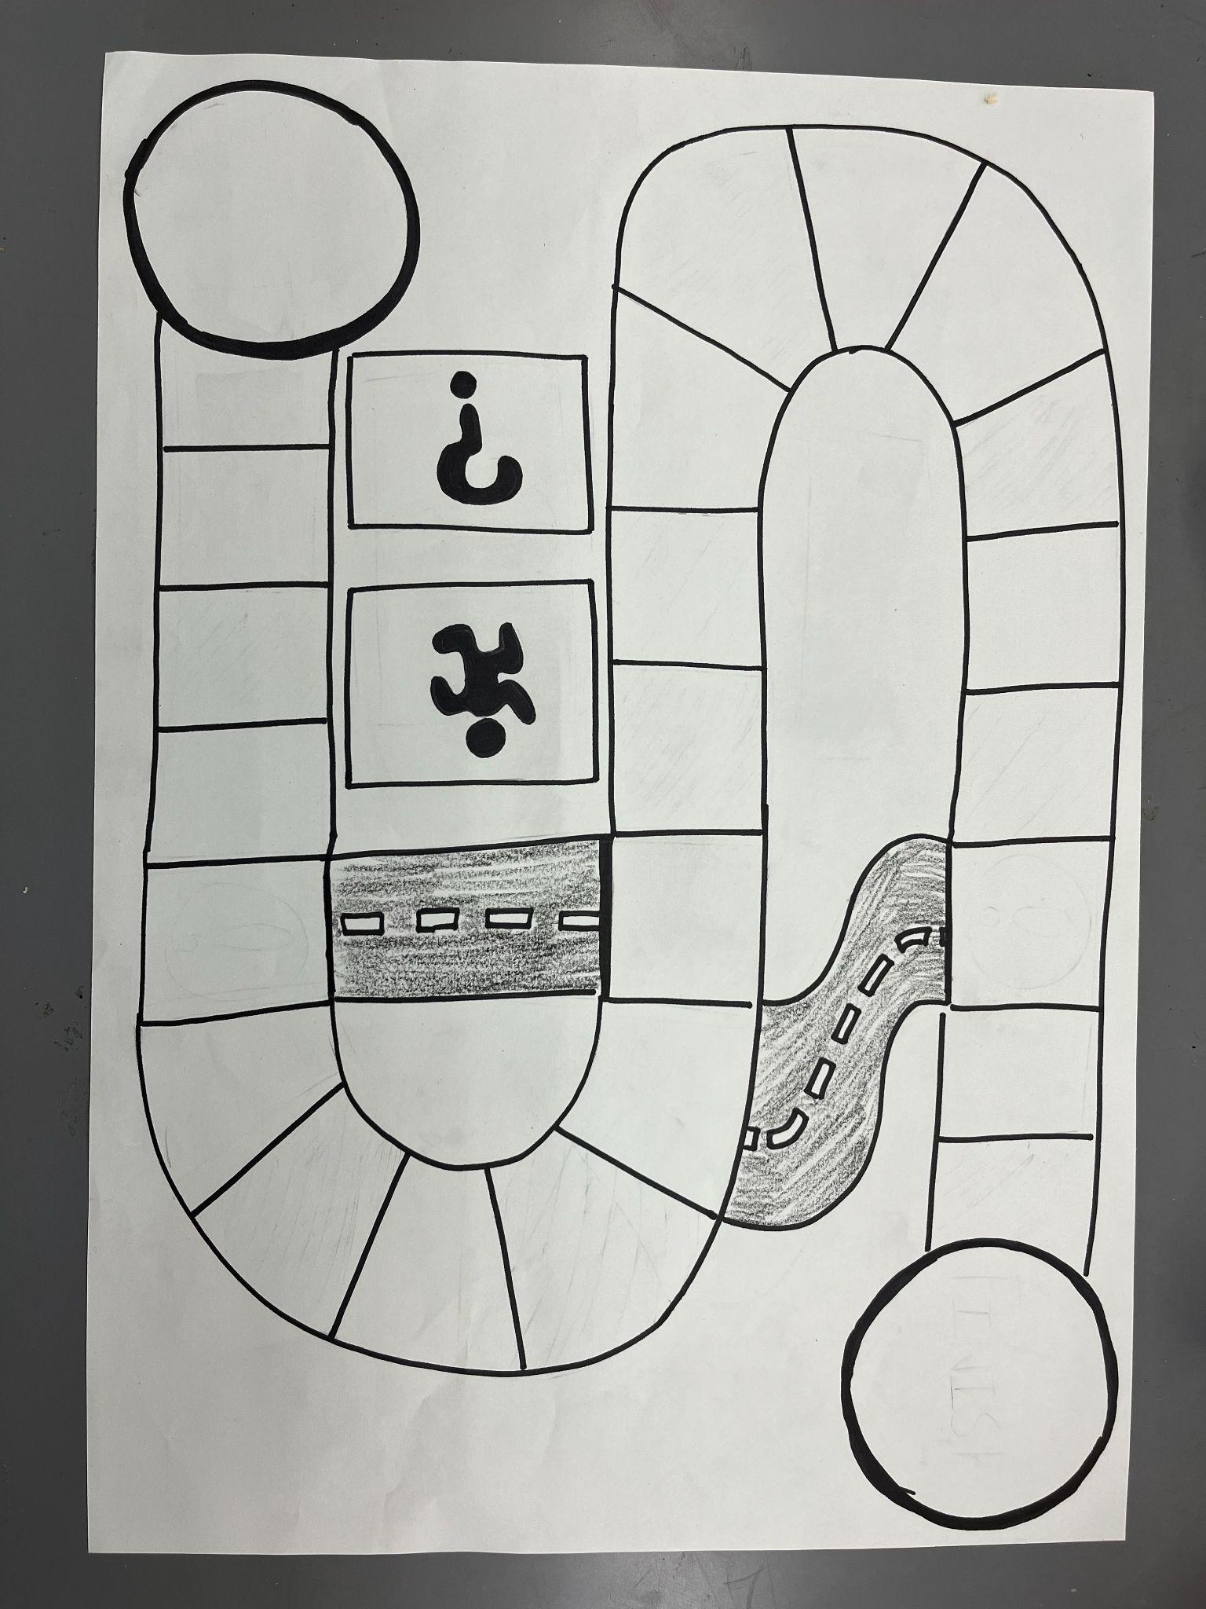
For the action cards, one side should have a silhouette of a moving person, like a street or floor sign, and the other should have an action or number (Ex: One, Two, Three, Move ahead 4 spaces, move ahead 3 spaces with a friend, move back 4 spaces, send an opponent back 3 spaces, go back to start, etc.)
For prizes, I use a sticker bag. The students reach in and grab one random sticker. Gives some surprise to winning, like a lottery.
**Image at the bottom made by Molly Bryant**

