Structured Discussion and Light Intro to Debating!
Class time needed for lesson: Two total sessions: first a 5-minute introduction, then a full 55-minute class period
Class size taught: 27 - 40 students
Target audience: SHS 2nd and 3rd Years
Objective: In one class, students will be able to have a 35-minute discussion in small groups on two topics they will research beforehand.
目的：事前に調べておく 2 つのトピックについて小グループで 35 分間ディスカッションできるようになる。
Materials: Discussion preparation worksheet, some kind of toy or ball for students to pass/throw (one per group), optional slides to project useful info/instructions during the discussion.
Procedure:
- End of previous class: Introduction - 5 minutes
  - Note: this lesson was originally made for Chapter 8 “What Can We Do to Help Stop Child Labor?” of the SDGs x Discussion textbook. This class of 2nd year students is advanced in English, but this lesson plan should be pretty easy to adjust for lower English levels by simplifying the topics.
  - The teacher explains to the students that in the next class, they’ll be having a discussion in small groups.
    - Distribute their discussion preparation worksheets.
    - Split students into desired discussion group sizes and split each group in half into Students A and Students B (for this class, there were three groups of nine students - see image below).
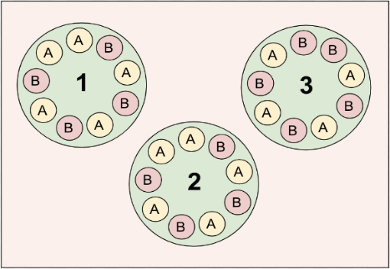

  - The discussion will be centered around two topics/statements:
    - Statement 1: Increasing access to schools is the most important step to end child labor.
      - Students A: AGREE
      - Students B: DISAGREE
    - Statement 2: Governments should be responsible for stopping child labor.
      - Students B: AGREE
      - Students A: DISAGREE
  - The students circle their assigned roles for each statement on their worksheet.
    - Note: the teachers can help students get research started by explaining that for both “DISAGREE” sides, they should research what other options exist and which of those options the students would like to say are better than the one in the statement.
  - Homework - for the next class, the students need to complete their worksheet by doing research and preparing notes for the discussion.
    - Tell the students that their grade for the discussion will be based on the quality of completion of the worksheet (which indicates their level of preparation).
    - Note: if time allows, students can start research at the end of this class. If students are lower level, this whole class could be spent doing research together in their A and B groups.
- Main Class: Preparation, Warm-Up, Useful Phrases - 15 minutes
  - At the beginning of class, the students move their desks/chairs into circles in their assigned discussion groups (like in the image above).
  - Share research and ideas (10 mins): students sit in their respective A and B groups and share their research and ideas. This will help warm them up for the discussion and start talking about these topics.
  - Fun warm-up question (5 mins): Back in their discussion groups, the teacher starts with a fun warm-up question (e.g. “If you could have any superpower, what would it be and why?”) to get everyone talking.
    - Give each group a ball/toy and tell the students to pass it around so that every person has the chance to speak.
    - Students freely share their answers for this for 5 minutes.
  - As a class, quickly review useful discussion phrases on their worksheet.
- Main Activity - 35 minutes
  - The teacher explains how each statement’s discussion round will work. Each discussion is broken up into three parts:
    - Part 1 (5 mins): Both A and B students share their assigned opinions, ideas, research, etc.
    - Part 2 (5 mins): Both A and B students recap the opinions and ideas of the OTHER side. This helps to make sure they’re listening to and understanding each other.
    - Part 3 (5 mins): Students drop their assigned roles and discuss their personal opinions on this subject now that they’ve done their own research and heard the opinions of the other side.
  - The discussion starts! Each statement and the instructions for each part can also be projected onto the board as a reference for the students.
    - Use a timer and let students know when the rounds start and end.
    - Walk around and monitor the students.
  - Note: if students are quiet and hesitant to voluntarily start talking, the ball/toy system can be used so that they have to keep passing it around and whoever has it needs to talk. Conversely, if students are eager and talking over each other, the ball/toy can help maintain order.
- Conclusion - 3 minutes
  - The teacher gives feedback to the class on things they did well during their discussions.
  - The teacher collects students’ discussion preparation worksheets to give them their grades.
Additional information:
- This lesson plan was sort of a scaffolded intro to the idea of debating, as the goal for this 2nd year class is that they will start debating later in the year.
- The worksheet for this class is very simple and includes:
  - The statements/topics and the assigned stance of the A & B students
  - Plenty of room for them to write their research and reasons
  - A short list of helpful discussion phrases

D&D Unit 8 - “What Can We Do to Help Stop Child Labor?” Discussion

STEP 1:
- Circle what group you are in: Group 1 / Group 2 / Group 3
- Circle your role for the discussion: Student A / Student B
STEP 2: Start with some general research on the issue of child labor – what are the basic facts? Where is child labor still a large problem? What are the causes of child labor? How can we help stop child labor?
Statement 1: Improving access to schools is the most important step to stop child labor.
- AGREE: Students A
- DISAGREE: Students B
General notes:
Find 2 or 3 pieces of data, examples, etc. that support your role’s stance on this question:
Statement 2: Governments should be responsible for stopping child labor.
- AGREE: Students B
- DISAGREE: Students A
General notes:
Find 2 or 3 pieces of data, examples, etc. that support your role’s stance on this question:

Discussion Expressions:
- I’m afraid I don’t agree with you…
- I see your point. However…
- I think that / I don’t think that…
- My research shows that…
- In my opinion…
- I agree with you because…
- Personally, I think…

