Halloween Kindergarten Lesson
Class time needed for lesson: 50 minutes
Class size taught: Any size
Target audience: Kindergarten
Objective: To learn about Halloween related vocabulary and have fun doing games and arts and crafts.
目的：ハロウィーンに関連した語彙を学び、ゲームやアート、工作を楽しむ。
Materials: Print out of vocabulary cards, paper, markers, paper bags, tape if necessary
Procedure:
- Introduction - 5 minutes
  - ALT will greet the students with their usual greeting routine.
  - The ALT will then ask the students about Halloween and what they do for it
  - The ALT will then give a brief explanation of what they did for halloween as a kid.
- Vocabulary - 5 minutes
  - The ALT will use flashcards or printouts depicting images of the vocabulary to be used. Images are much easier for the young students to understand as they also might not know even hiragana at that age.
    - For halloween this could include vocabulary such as pumpkin, bat, ghost, witch, spider, etc.
    - The ALT should keep the amount of vocabulary to an appropriate amount based upon their age. For younger students this may be as little as 5 vocabulary words.
  - The ALT will read the vocabulary to the students several times.
    - This is a very boring part of the lesson but is necessary to do the rest of the activities.
      - Doing actions, gestures, sound effects and other physical movements could help the students be more engaged and enjoy learning the vocabulary.
- Warm Up - Touch the Vocab Game - 5 minutes
  - With the help of the other teachers in the class, the ALT will put flashcards with images of the vocab all over the classroom in areas that the students are able to reach.
    - There needs to be multiple of each flashcard to help reduce the chaos.
    - If the class is a large class then the teachers might need to separate the students into different groups and take turns.
  - The students will gather in the middle of the room where the flashcards are all visible.
  - The ALT will say one of the vocabulary words randomly.
  - The students will run to the flashcard with that vocabulary on it and touch it.
    - This can be very chaotic and some teachers will want the students to walk rather than run.
  - After touching the flashcard, the students will return to the middle of the room and sit down.
  - The ALT will repeat this game as many times as desired to help the students learn the vocabulary.
    - If the ALT wants to increase the difficulty, multiple vocabulary words can be called out at once. Can also have them touch the cards in a specific order.
- Arts and crafts - Ghost Hand Version 1
  - ALT and teachers will hand out pieces of paper to the students.
  - The ALT will then demonstrate by using either the board or their own paper how to make the ghost hand art.
    - The students place one of their hands on the paper
    - The students then draw an outline of their hand and then connect the gap where the wrist is.
    - Students will rotate their paper 180 degrees.
    - The students will then draw a face on the hand.
      - The ALT should encourage the students to customize their drawing and add things the students like to it.
    - Finish
- Arts and crafts - Ghost Hand Version 2
  - Same as version 1 but instead of being drawn on pieces of paper, it is done on brown paper bags.
  - On one side of the bag the students will draw their hand ghost.
  - On the opposite side of the bag, the students will draw other halloween themed items such as a jack-o-lantern.
  - This bag is a trick or treat bag for the students.
- Conclusion - 5 minutes
  - The ALT will wish everyone a happy halloween and then hand out appropriate candy or snacks.
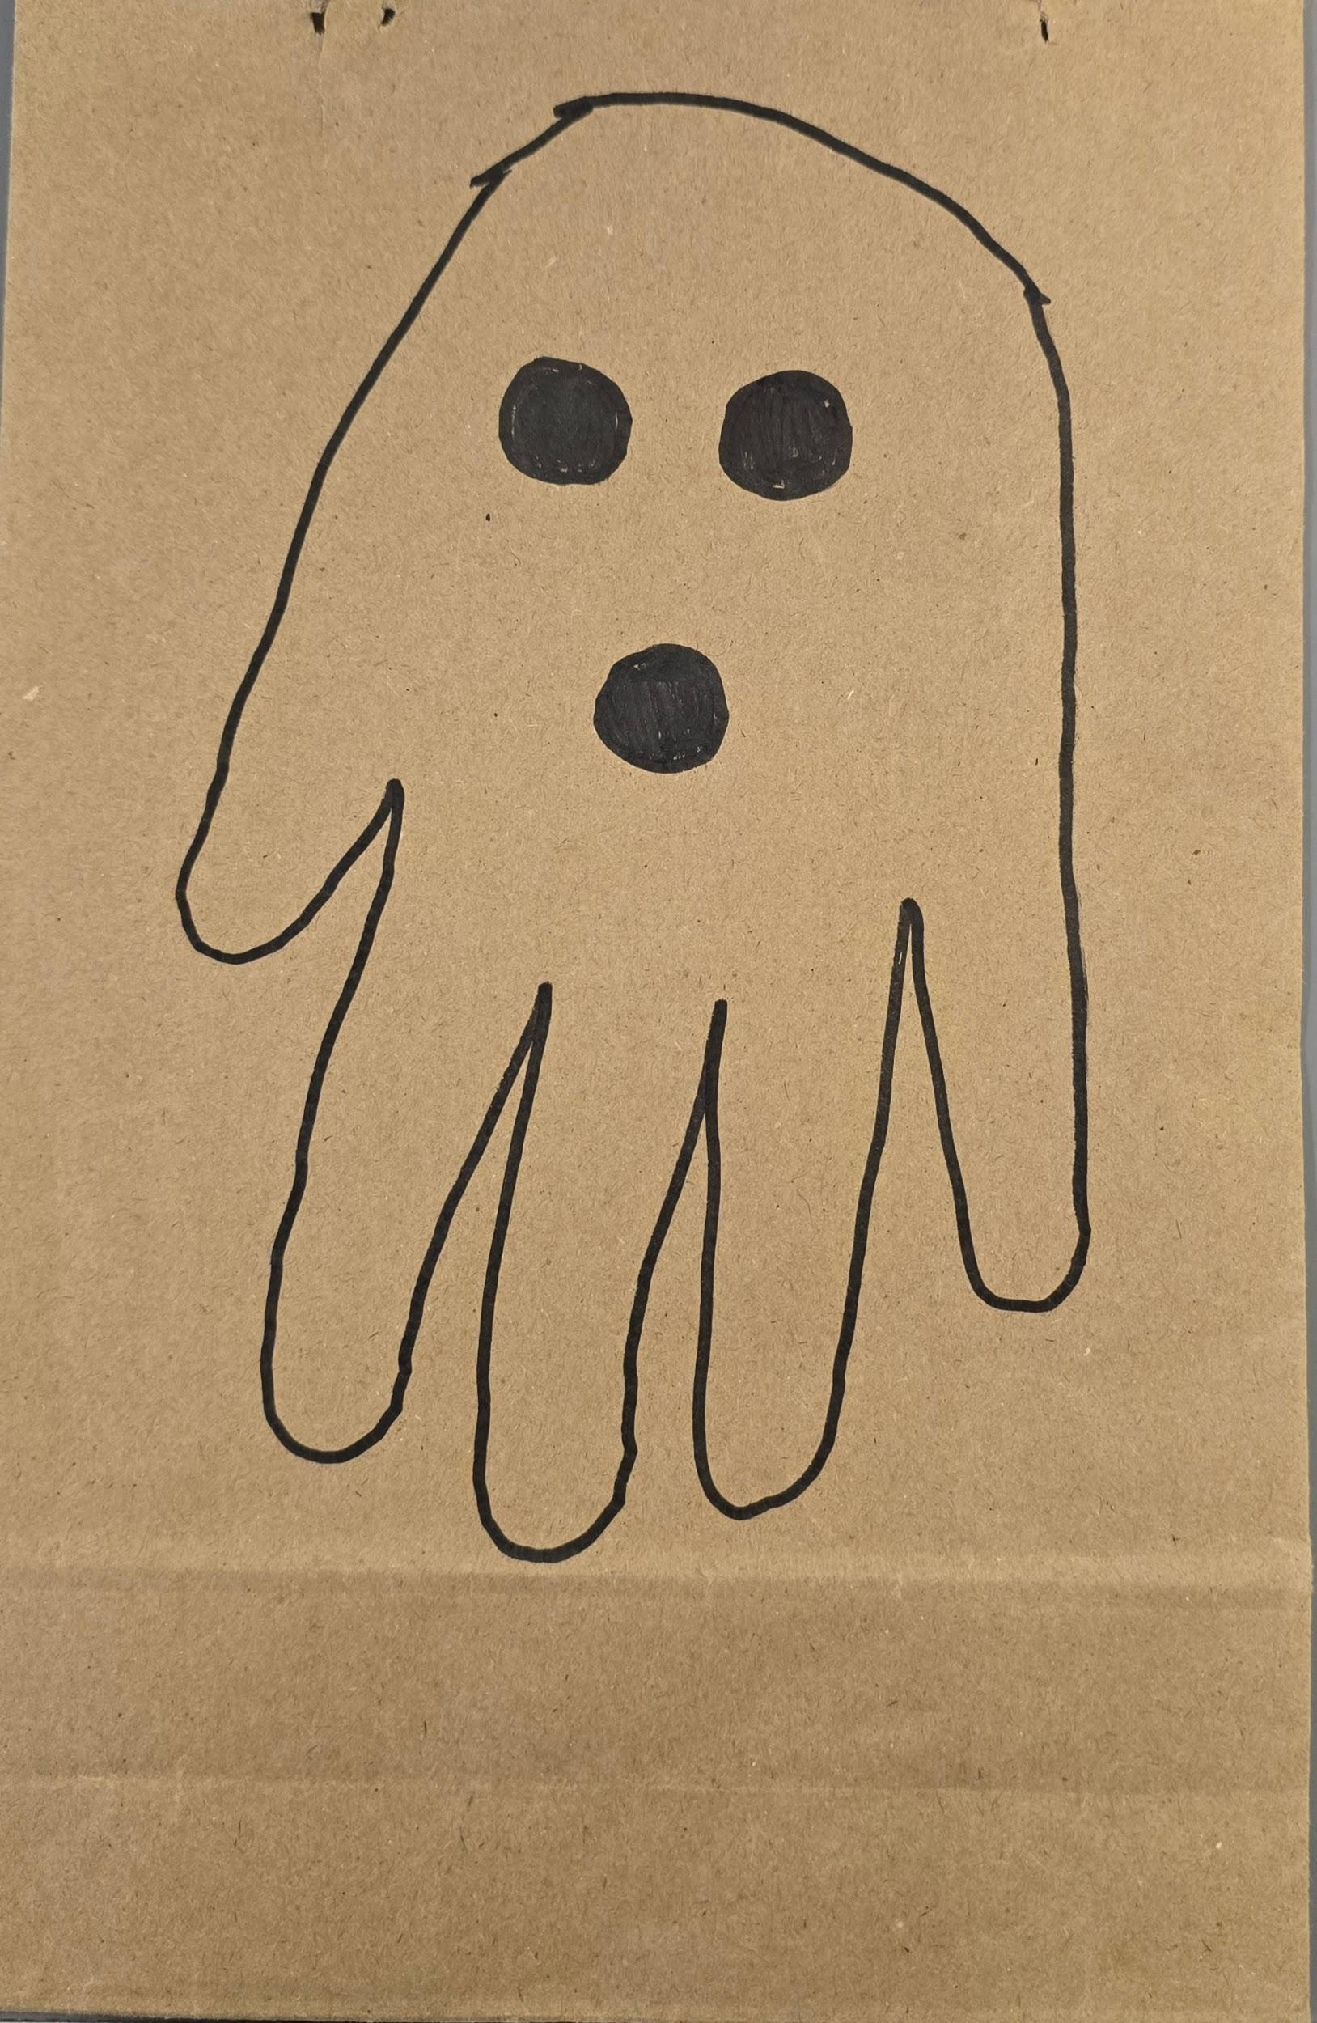
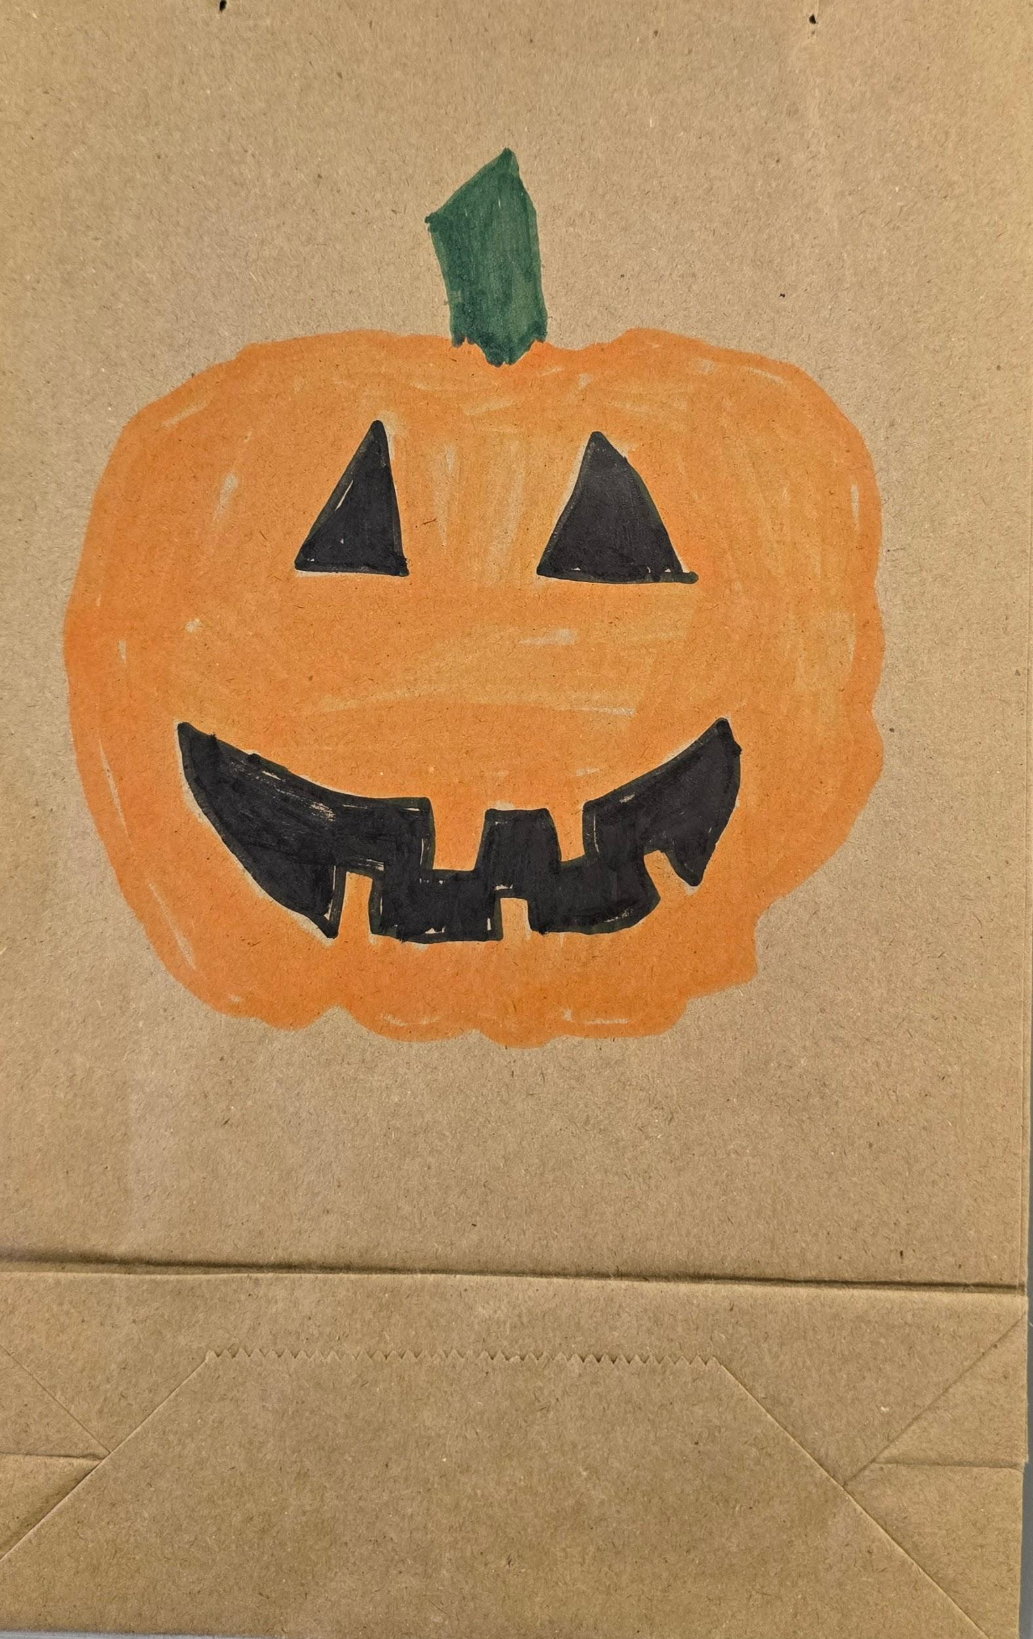
    - Senbei is often the best option and can be very cheap to buy.

Additional information:
Children this age are very sensitive to how the teacher is feeling and so the ALT needs to be as enthusiastic as they can be and to never get upset with the children. When the class gets too rowdy and hard to control, the primary kindergarten teachers should step in and help the class settle down. It is perfectly fine to rely upon the primary kindergarten teachers and ask them for help.
Children at this age respond best to physical activities as it gets them moving, motivated, and having fun. Focusing too much on repeating the vocabulary cards at the start of the lesson will cause the children to lose interest which can be hard to get back. Remember to have fun! The more fun you have, the more fun the children have!

