Zombie Game
Class time needed for lesson: 20 minutes
Class size taught: 10 students minimum
Target audience: ES 5 - SHS 3
Objective: Students will be able to review speaking points in a fun game that teaches teamwork and fosters English grammar retention.
目的：チームワークを高め、英語の文法の定着を促す楽しいゲームを通じて、スピーキングのポイントを復習することができる。
Materials: zombie, doctor, and student cards or slips of paper, a timer, and larger cards for the blackboard
Procedure:
I. Introduction - 10 minutes
- The ALT and JTE will explain the rules of the Zombie Game, then hand out 1 card to each student, face down.
II. Zombie Game - 8 minutes
- After every student has a card, the JTE and ALT will start the timer. Students will walk around the room talking to each other.
- Everyone asks each other the same question: “What food do you like?”
  - Those with student and doctor cards answer normally with their favorite foods. Example: “I like sushi/pizza/ice cream.”
  - Those with zombie cards answer as a zombie would. Example: “I like brains/people.”
  - Doctors can heal zombies by saying: “That’s bad!/Don’t eat people.”
- If a zombie meets a student, the student turns into a zombie.
- If a zombie meets a doctor, the zombie turns into a student.
- Everyone has to remember what they are at the end of the timer to be able to count the points properly.
  - Example: START = student….zombie….student…zombie. END= zombie
III. Conclusion - 2 minutes
- At the end of the timer, the ALT and JTE ask the class who is what at the end of the game. They start with counting the doctors since there is always the same amount from start to end. Then they count the points for students. Then the points for zombies.
- If there are more zombies than students by the end of the timer, then the zombies win. If there are more students than zombies by the end of the timer, then the students and doctors win.



Additional information:
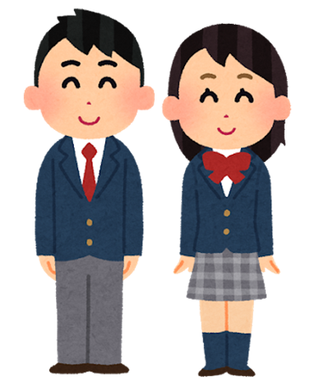
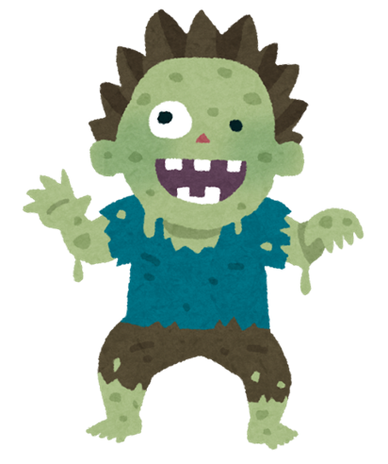
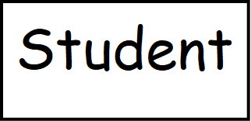
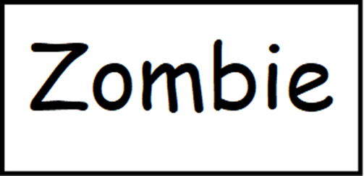
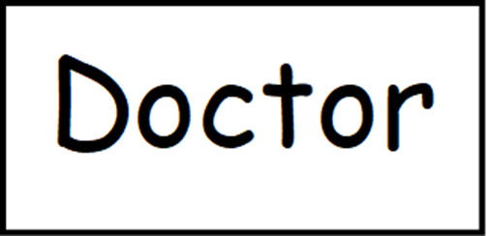
*Here are examples of the cards you can make for the game. You can also write the words on slips of paper and put them in a bag for students to draw out.
**The students don’t need to exchange cards if they turn into a zombie or back to a student, they only use the cards as a starting point to know their role in the game.
***They have to remember what they are and if they change throughout the game.

