Tokyo Metro Stamp Rally
Class Time: 50 minutes
Class Size: ~35 students
Target Audience: JHS 3年
Objective: Students will learn key phrases for explaining directions.
目的：生徒は道順を説明するための基本的なことを学びます。
Materials: Textbook (Sunshine Program 3 Power Up pg 39), Activity Worksheet, Activity Stamp Book, Tokyo Metro Route Map, a stamp, optional prize for completing stamp rally
Procedure:
- Introduce - 10 minutes
- HRT introduces the lesson with the textbook dialogue. Have students repeat the conversation after the ALT/JTE and then have them role play the dialogue with a partner. Confirm their understanding before moving on to the activity.
- Explanation and Activity - 45 minutes
  - Split students into groups or pairs.
  - Hand out worksheet (1 per student), Stamp Book (1 per group/pair), and the map of Tokyo Metro Routes (1 per group/pair). Briefly explain that today’s goal is to practice giving directions and encourage students to use as much English as they can.
    - The worksheet has dialogue and the stamp book is to keep track of their progress.
  - Students will come up to the ALT or JTE whenever they’re ready. Once they’ve completed a dialogue, ALT/JTE will stamp their booklets and they can continue to the next location.

Additional Information:
- Both the ALT and JTE will need to play the role of the traveler, otherwise there will be a traffic jam of students waiting around for their turn.
- The booklets will take some time to prepare beforehand, so plan accordingly.
- The activity requires students to have some initiative, so it might start slow, but after they get the hang of it, the activity will speed up.

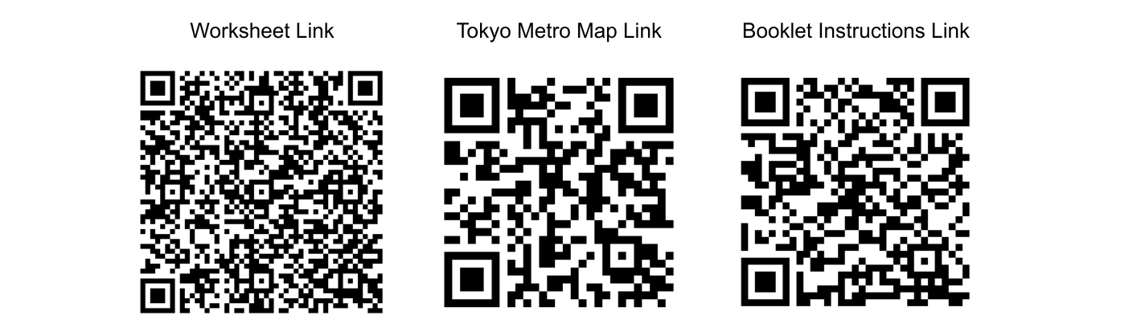

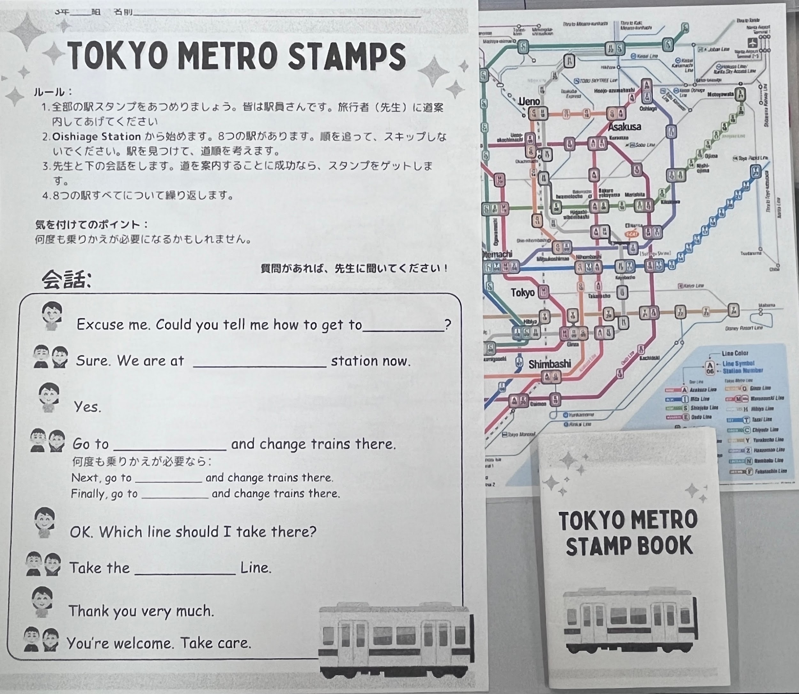
Each group will get: 1 Subway Map, 1 Stamp Booklet, Worksheet (one per student)

