Takenoko-Takenoko-Nyokiki Review Game
Class time needed for lesson: 10 mins
Class size taught: 24-33 (might be difficult if over 40)
Target audience: ES 5th and 6th graders; suitable for any grade level
Objective: In ten minutes, students will review and be able to quickly pronounce target vocabulary/phrases.
目的：学生は目的の単語や表現を復習し、早く発音することを学ぶことができる。
Materials: prepared flashcards of target vocabulary/phrases, board, board magnets

Procedure:
- Introduction/Review – 5 mins
  - Introduce/review the vocabulary with the ALT.
    - If new vocabulary, students repeat after the ALT twice. If reviewing, students say it by themselves, then repeat after the ALT for pronunciation confirmation.
    - Place each of the flashcards as you review it with magnets on the board.
- Takenoko-Takenoko-Nyokiki Game – 5 mins
  - Explain the rules of the game.
    - Students must say the vocabulary or learned phrase in the order written. Students cannot speak at the same time. When saying the vocabulary/phrase, it must be accompanied by a gesture (clasp their hand above their head, refer to Illustration 1).
  - Play the game.
    - Students will chant and clap in the following order: takenoko (clap), takenoko (clap), nyo-ki-ki (clap-clap-clap).
    - Students say the vocabulary or learned phrase, one by one, in the order on the board accompanied with the gesture.
    - The student who says the last word/phrase is the winner.

Additional information:
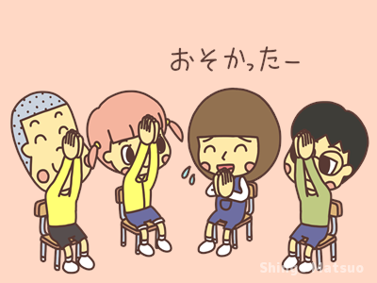
Illustration 1. Gesture for the takenoko-takenoko-nyokiki game.
It is possible to make the game more interesting by giving a reward to the winner students (stamp, stickers, etc.) However, the game tends to get quite competitive and the students are not able to finish a round (due to several students aiming to get the last vocabulary/phrase). One solution to that would be to give out stamps to all the students that participate in one round to encourage collaboration as opposed to competition for the last vocabulary word/phrase.
The game can be played for more than one round (5+ mins).

