Libbin' It Up
Class time needed for lesson: 20-45 minutes (depending on how many stories are used)
Class size taught: ~40 students
Target audience: Senior high school
Objective: Students will be able to identify the parts of speech of English words, connecting their Japanese grammatical knowledge with English
目的：日本語の文法知識と英語を結びつけながら、英単語の品詞を識別できるようになる。
Materials: Worksheet, computer, screen, blackboard

Procedure:
- Introduction - 5 minutes
- The ALT introduces and explains the activity to the class.
  - The objective of the activity is to fill in blank words in a story. Each blank word has a category based on a part of speech (noun, adjective, verb, or adverb).
  - The story is hidden from the class until it is completely filled in. When it is filled in, the ALT reveals the story and reads it with the class.
- The ALT then briefly reviews the parts of speech and provides a word bank with examples of the different types of words.
- The ALT does a quick knowledge check of the parts of speech, asking the class what category a certain word is.
  - For example, the ALT asks the class if "banana" is a noun, adjective, verb, or adverb. This is done with at least one word for each part of speech.
- Main Activity - 15 minutes (repeatable depending on how many stories are used)
- Students receive a worksheet with the parts of speech, a word bank, and the blanks to fill in.
  - The ALT hides the slide with the story the class is on.
  - The ALT selects a student (either randomly or following the seating chart) and asks them to provide the class with a word from a certain part of speech. The ALT then fills in the word on the presentation, which is hidden from the class, and writes it on the board, while the class writes the word on their paper. This continues until the story is fully filled in.
  - When the story is fully filled in, the ALT reveals the completed story on the screen. The ALT then reads the story with the class.
Additional information:
- Notes on procedure
I recommend that you use this activity with fairly advanced students that have a good grasp of the parts of speech (either in Japanese or English). I intended for this activity to help students connect their background knowledge in Japanese with English, but it instead overloaded them with too many new concepts at once.
Additionally, I recommend that you encourage students to use weird words to make the story more interesting!
Because the blank words are organized into a list, it should be easy for students to follow along with the class and know where they are in the story. Often these stories require a specific sort of noun (like a number, unit, location, etc) which you should explain as you encounter them with the class.
Students may not understand the story at the end, so having the JTE translate it might be useful.
- Notes on story creation
Writing a story conducive to the activity can be a bit challenging at first, but it's quick to get used to after reading stories from similar games. You basically take a fairly cliche or mundane event, and then take out all of the important subjects/objects and verb phrases so that the class can fill their own in. A good way to make the story fun for students is to have named characters (which usually end up being you or some other teacher!). I'd keep the number of blank words in each story at around 12 since the activity tends to drag with any more. Some of my own stories are available in the presentation shared below.
- Notes on the worksheet
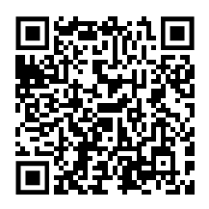
In the worksheet I included a definition for the parts of speech in English and a Japanese translation of them. I also included a fairly sizable word bank. I recommend that the word bank be removed entirely, and instead be filled with examples of different types of words within a part of speech, like food/animals/famous people for nouns, colors/textures/feelings for adjectives, etc.
Presentation QR code
Document QR code


Libbin' It Up
Parts of Speech (語類)
Noun (名詞): person, place, thing

Verb (動詞): action word
Adjective (形容詞/形容動詞): description word for noun

Adverb (副詞): description word for verb

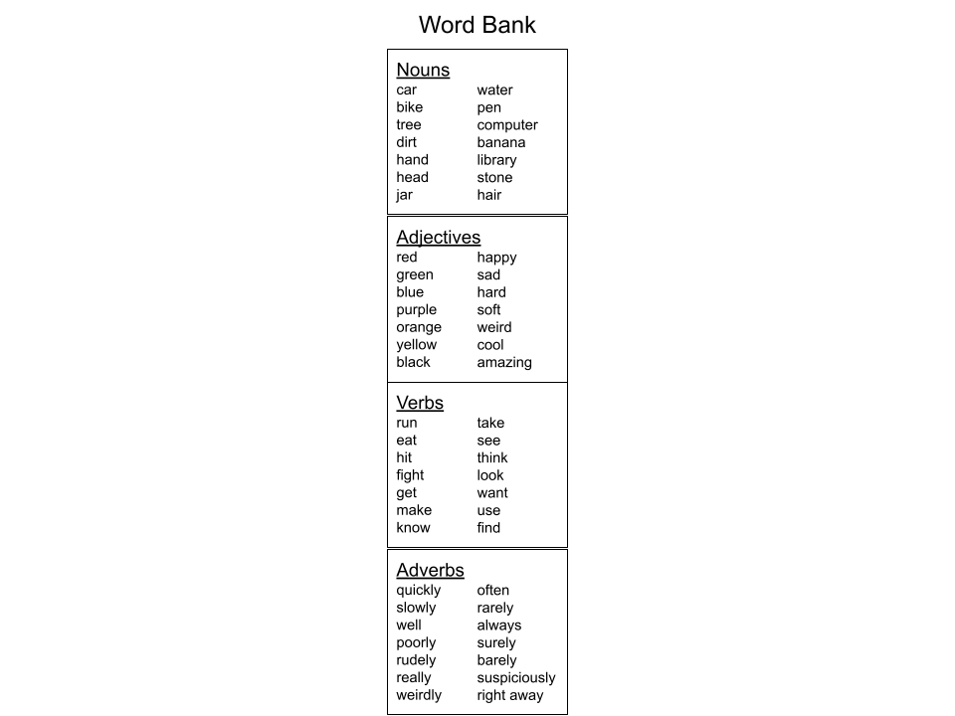
Story Number 1
JOB (NOUN):
ADJECTIVE:
VERB:
NUMBER:
UNIT OF TIME
(seconds/minutes/days/years):
ADVERB:
NOUN:
NOUN:
ANIMAL (NOUN):
VERB:
BODY PART (NOUN):
VERB:
ADJECTIVE:
NOUN:
FEELING:

