This, That, or Thaaaaaat (over there)
Class time needed for lesson: 10 minutes minimum
Class size taught: Full class (~20 students)
Target audience: 1st year middle school students
Objective: In ten to twenty minutes, students will better understand the differences between this and that as it relates to proximity to the speaker. As an added bonus students can practice the phrases “I want OO” and “this/that is OO”.
目的: 生徒は話者との距離に関するこれとあれの違いをよりよく理解できるようになる。
Materials:
- A small to medium sized bag that is not see through and as many SMALL random items as there are students (include at least one more for yourself or JTE). I prefer to use random “gatcha” I have collected over time, stickers, or other small silly items.
- A brief slide presentation to explain proximity and the key phrases: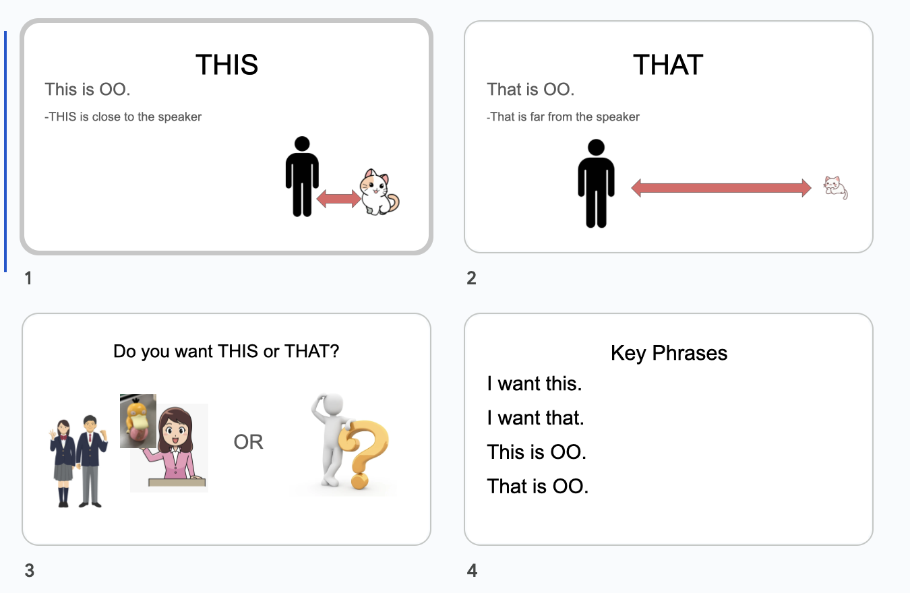

Procedure:
- From the bag pull out one item and show it to the class.
- Set the item on a table or desk at the front of the class.
- Hand the “mystery” bag (bag with items) to the JTE and have them stand in front of the classroom.
- Now you (the ALT) simply have to choose if you want this (the item on the front desk close to you) or that (a mystery item from the bag).
- Choose the item that has already been revealed. Say “I want THIS” (the item close to you on the desk)
- Take the item.
- Say the name of the item. “This is a Pokemon” (referencing the gatcha from the photo)
- Select a student on either end of the front row to begin (furthest left or right)
- Ask the student if they want this (the item you’re holding) or that (to choose from the bag). Say, “Do you want this or that?” (while pointing)
- The student will choose if they want your item or a mystery item.
  - If from the ALT- “ I want this”
    - Hand the student the Pokemon (in this example)
  - If from the JTE- “I want that”
    - The student will walk to the JTE and take one item from the bag
    - The student will announce the item. “This is OO” and return to their desk
- The same student will now ask the student to their immediate right, left, or rear “Do you want this (what they are holding) or that (pointing at the Jte’s bag)
- Repeat from number 10 until all students have answered
Additional information:
You can also just print and cut out pictures and use an envelope if you don’t want to use anything you own. You can add different phrases to meet different grammar patterns.
“I have Hello Kitty. She is cute.”
“I have Doraemon. He can help people.”

