Puzzle Relay - Subject-Verb Agreement (Third Person)
Class time needed for lesson: 35~50 minutes (can be adapted to be shorter as needed)
Class size taught: 30~35
Target audience: 1st grade JHS (designed for the NEW HORIZON Unit 5 grammar)
Objective: In one lesson, students are to review the subject-verb agreement by practicing using verbs in the third person singular present tense form through a fast paced, fun and interactive relay game.
目的：テンポがよく、楽しく、インタラクティブなリレーゲームを通じて、三人称単数現在形の動詞の使い方を練習し、主語と動詞の一致について理解を深めることができる。
Materials: 1 set of 16 verb cards per group (with puzzle on back), an answer sheet with fill-in-the-blank sentences per student (see QR code), and scissors.

Procedure:
- Introduction (Review of Grammar) - 10~15 minutes
- Ensure the students are familiar with the subject-verb agreement. Review with your JTE, as students may or may not have studied it before.
- Practice examples of the first person singular verbs e.g. “I eat breakfast” and the third person singular verbs e.g. “He/she eats breakfast” with students (I went through all the verbs written on the cards).
- Main Activity - 20~25 minutes
- Divide students into groups of 4–6 depending on the size of the class.
- Lay out each group’s set of character cards in separate areas of the room and ensure that the groups know which set is theirs.
- Give each student an answer sheet.
- Explain the rules through a demonstration with your JTE.
- The first student will find the character that corresponds with the first question on the answer sheet (e.g. “Ben….……pasta for dinner” → find the 'Ben' card). The verb on this card is used to fill in the blank on the answer sheet.
- They then read the full sentence aloud to a teacher (e.g. “Ben eats pasta for dinner”).
- The student can then take that card back to their group and tag the next student.
- Once the group has collected all 16 cards, they can solve the puzzle that is on the back of the cards.
- Emphasize that they must not begin solving the puzzle until they have collected all 16 of the cards.
- The first team to finish the puzzle wins.
- Conclusion - 5~10 minutes
- Congratulate the winners and give them a prize (e.g. stickers or stamp).
- Allow time to complete answer sheets, clean up and return cards.

Additional information:
- You may need to review the pronunciation of the foreign names on the character cards if the students are unfamiliar.
- Print the character cards and victory image double-sided so the puzzle appears on the back when cut.
- Here is what I did for a filler activity if you have time remaining:
- Each student chooses a character card and walks around the room introducing their characters (e.g. “This is Sophie, she drinks tea everyday”).
- After both students introduce their characters, they swap cards and find new partners.
- Please feel free to reach out if you would like the original copy of the resources! LINE ID: 52644244.

QR Code for Activity Worksheets:
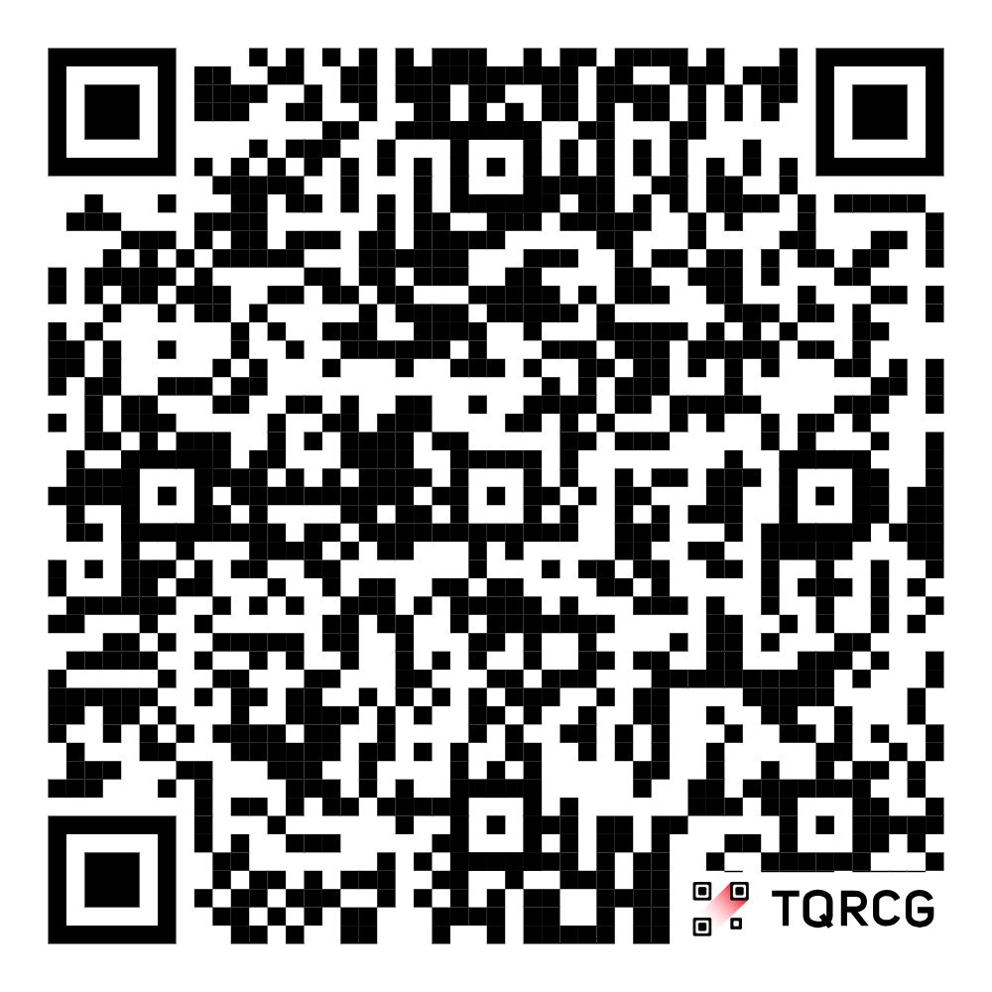

https://drive.google.com/file/d/1Zb0LybBYnfzlmcdvO--1HmPw1OLufKtN/view?usp=sharing

